I use **KUBEADM** and refer at: [[ LINK REFER ]](https://kubernetes-io.translate.goog/docs/setup/production-environment/tools/kubeadm/?_x_tr_sl=en&_x_tr_tl=vi&_x_tr_hl=vi&_x_tr_pto=tc)

* Install the necessary components for Kubernetes on 3 node.
* Turn off swap, configure kernel, install containerd as container runtime.
* Install kubeadm, kubectl, kubelet.
* kubeadm: the command to bootstrap the cluster
* kubelet: the component that runs on all of the machines in your cluster and does things like starting pods and containers
* kubectl: the command line util to talk to your cluster

| **Hostname** | **OS** | **IP** | **RAM (minimum)** | **CPU (minimum)** |
| --- | --- | --- | --- | --- |
| k8s-master-1 | Ubuntu 22.04 | 172.16.146.111 | 4G | 2 |
| k8s-master-2 | Ubuntu 22.04 | 172.16.146.112 | 4G | 2 |
| k8s-master-3 | Ubuntu 22.04 | 172.16.146.113 | 4G | 2 |

**DO THIS ON ALL 3 SERVERS**

* Add hosts so each node can resolve each other's hostnames:

vi /etc/hosts

=======================

172.16.146.111 k8s-master-1

172.16.146.112 k8s-master-2

172.16.146.113 k8s-master-3

=======================

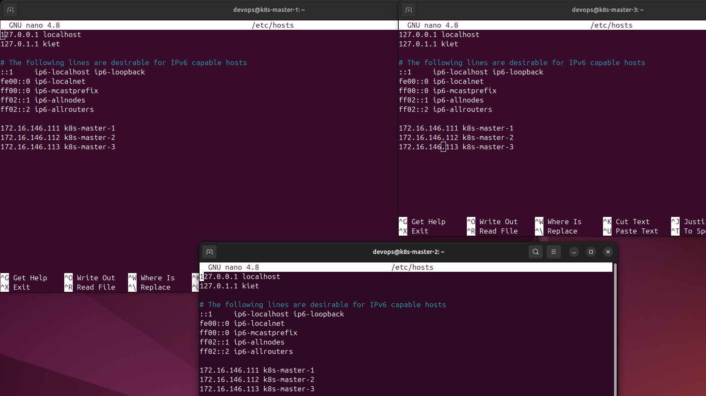

apt update -y && sudo apt upgrade -y

* Create user devops and switch to user devops:

adduser devops

usermod -aG sudo devops

su devops

cd /home/devops

* Turn off swap (Kubernetes Required):

sudo swapoff -a

sudo sed -i '/swap.img/s/^/#/' /etc/fstab

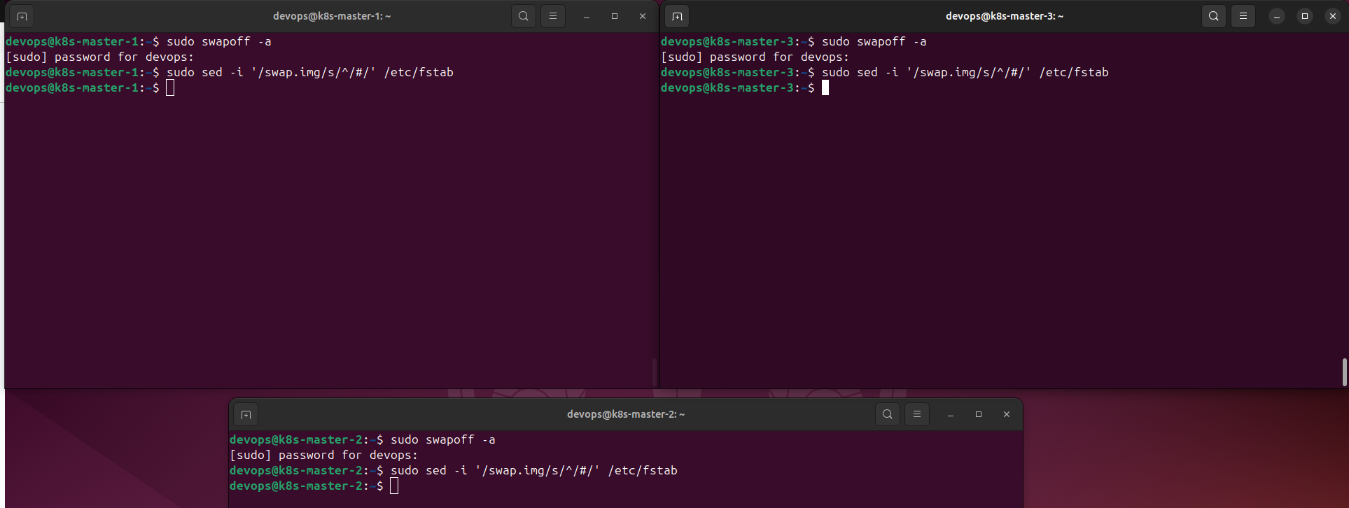

* Configure kernel modules:

sudo nano /etc/modules-load.d/containerd.conf

========

overlay

br_netfilter

========

*\*\*\* with:*

* **overlay** : supports file system overlay (for containers).
* **br_netfilter** : allows iptables to process traffic over bridges.
* Download kernel modules:

sudo modprobe overlay

sudo modprobe br_netfilter

* Network Configuration (set up the network configuration needed for Kubernetes to route and filter packets.):

echo "net.bridge.bridge-nf-call-ip6tables = 1" | sudo tee -a /etc/sysctl.d/kubernetes.conf

echo "net.bridge.bridge-nf-call-iptables = 1" | sudo tee -a /etc/sysctl.d/kubernetes.conf

echo "net.ipv4.ip_forward = 1" | sudo tee -a /etc/sysctl.d/kubernetes.conf

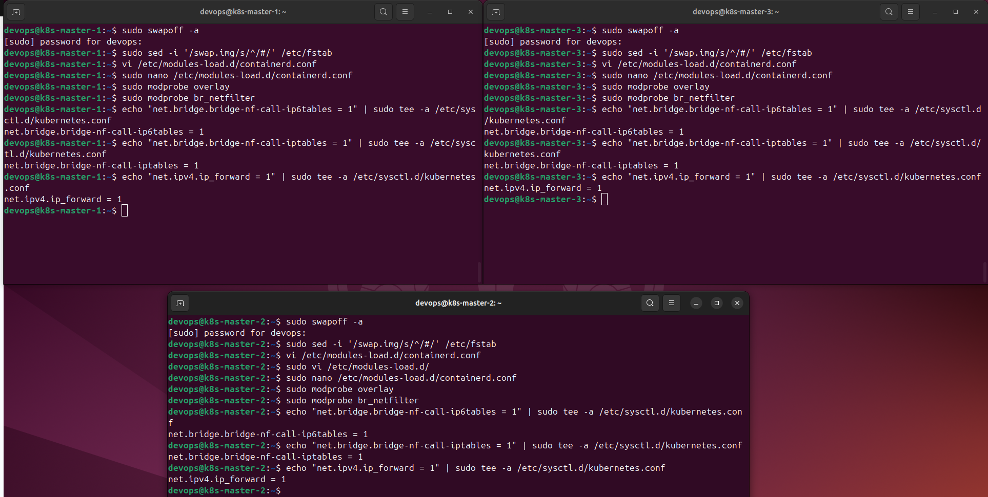

* Apply sysctl configuration:

sudo sysctl --system

* Install required packages and add Docker repository:

*# Install necessary packages*

sudo apt install -y curl gnupg2 software-properties-common apt-transport-https ca-certificates

*# Add Docker repository to install containerd*

sudo curl -fsSL https://download.docker.com/linux/ubuntu/gpg | sudo gpg --dearmour -o /etc/apt/trusted.gpg.d/docker.gpg

sudo add-apt-repository "deb [arch=amd64] https://download.docker.com/linux/ubuntu $(lsb_release -cs) stable"

* Install containerd:

sudo apt update -y

sudo apt install -y containerd.io

* Containerd configuration:

containerd config default | sudo tee /etc/containerd/config.toml >/dev/null 2>&1

sudo sed -i 's/SystemdCgroup = false/SystemdCgroup = true/g' /etc/containerd/config.toml

* Start containerd:

sudo systemctl restart containerd

sudo systemctl enable containerd

* Add a Kubernetes repository:

echo "deb [signed-by=/etc/apt/keyrings/kubernetes-apt-keyring.gpg] https://pkgs.k8s.io/core:/stable:/v1.30/deb/ /" | sudo tee /etc/apt/sources.list.d/kubernetes.list

sudo mkdir -p /etc/apt/keyrings

curl -fsSL https://pkgs.k8s.io/core:/stable:/v1.30/deb/Release.key | sudo gpg --dearmor -o /etc/apt/keyrings/kubernetes-apt-keyring.gpg

* Install Kubernetes Packages:

sudo apt update -y

sudo apt install -y kubelet kubeadm kubectl

sudo apt-mark hold kubelet kubeadm kubectl

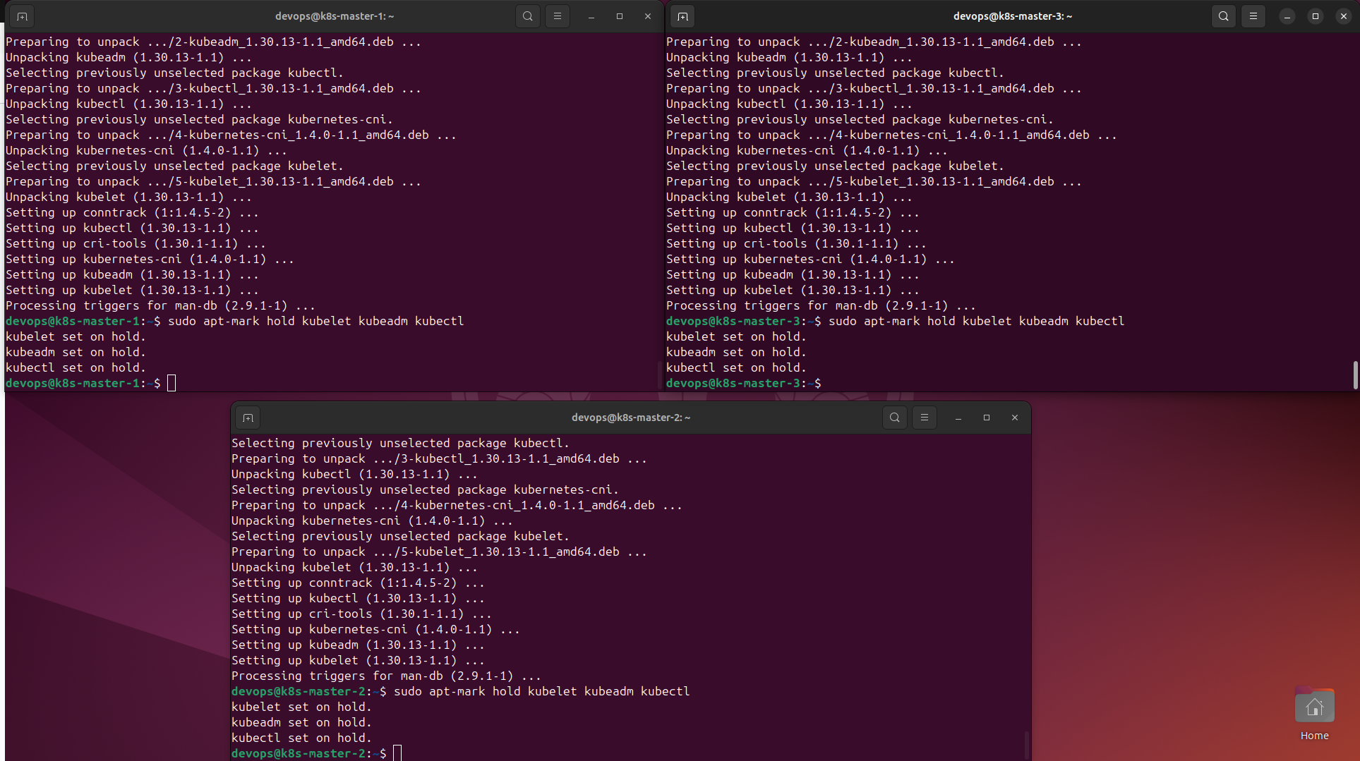

*\*\*\* with:*

* **kubeadm** : tool to initialize and manage K8s clusters.
* **kubelet** : agent running on each node to manage containers.
* **kubectl** : command line tool to administer clusters.

**Model: 1 master 2 worker**

* Executed on server **k8s-master-1** (write down the token and cert key because they will be used for node joins):

sudo kubeadm init

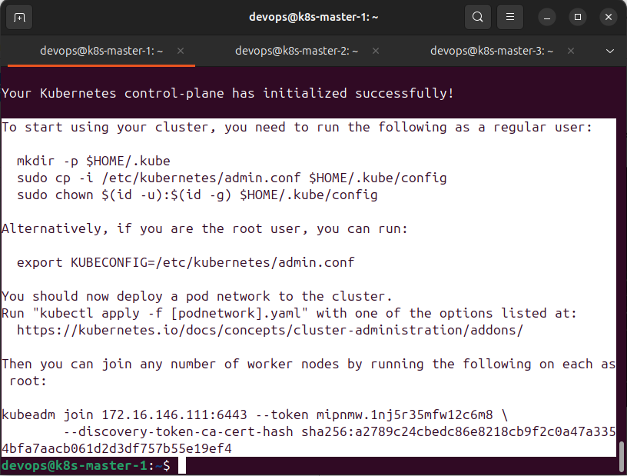

→ **Kubelet** will start monitoring and initializing the Pods needed to deploy on the master node.

* To start using my cluster, you need to run the following as a regular user:

mkdir -p $HOME/.kube

sudo cp -i /etc/kubernetes/admin.conf $HOME/.kube/config

sudo chown $(id -u):$(id -g) $HOME/.kube/config

* check node (control-plane):

kubectl get nodes

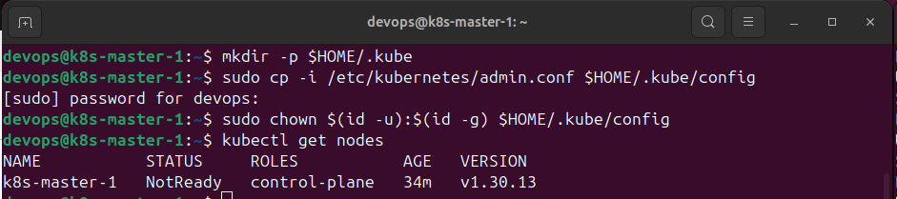

* Use below command to add server 2 and 3 into k8s cluster (run on **k8s-master-2 and k8s-master-3**):

**sudo kubeadm join 172.16.146.111:6443 --token mipnmw.1nj5r35mfw12c6m8 --discovery-token-ca-cert-hash sha256:a2789c24cbedc86e8218cb9f2c0a47a3354bfa7aacb061d2d3df757b55e19ef4**

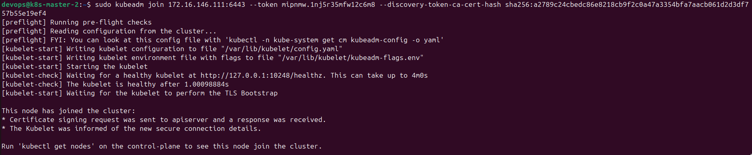

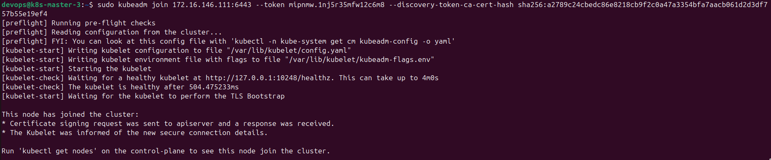

***→ kubelet*** *on the worker node will connect to the master node and start receiving tasks from the Kubernetes API server, which is responsible for initializing containers in Pods and managing their state on each worker node*

* check nodes in **k8s-master-1**:

kubectl get nodes

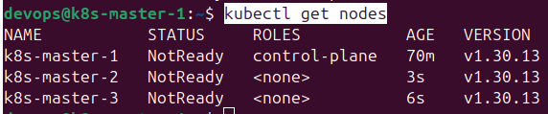

*\*\*\* with:*

* determine the ROLES of each node.
* status 'NotReady' because the network has not been installed for this k8s cluster, so the resources cannot be pulled back.
* To solve the 'NotReady' STATUS issue, add network **calico** on **k8s-master-1** (at ROLES control-plane) - This file declares all Calico pods and configurations such as DaemonSet, ConfigMap…

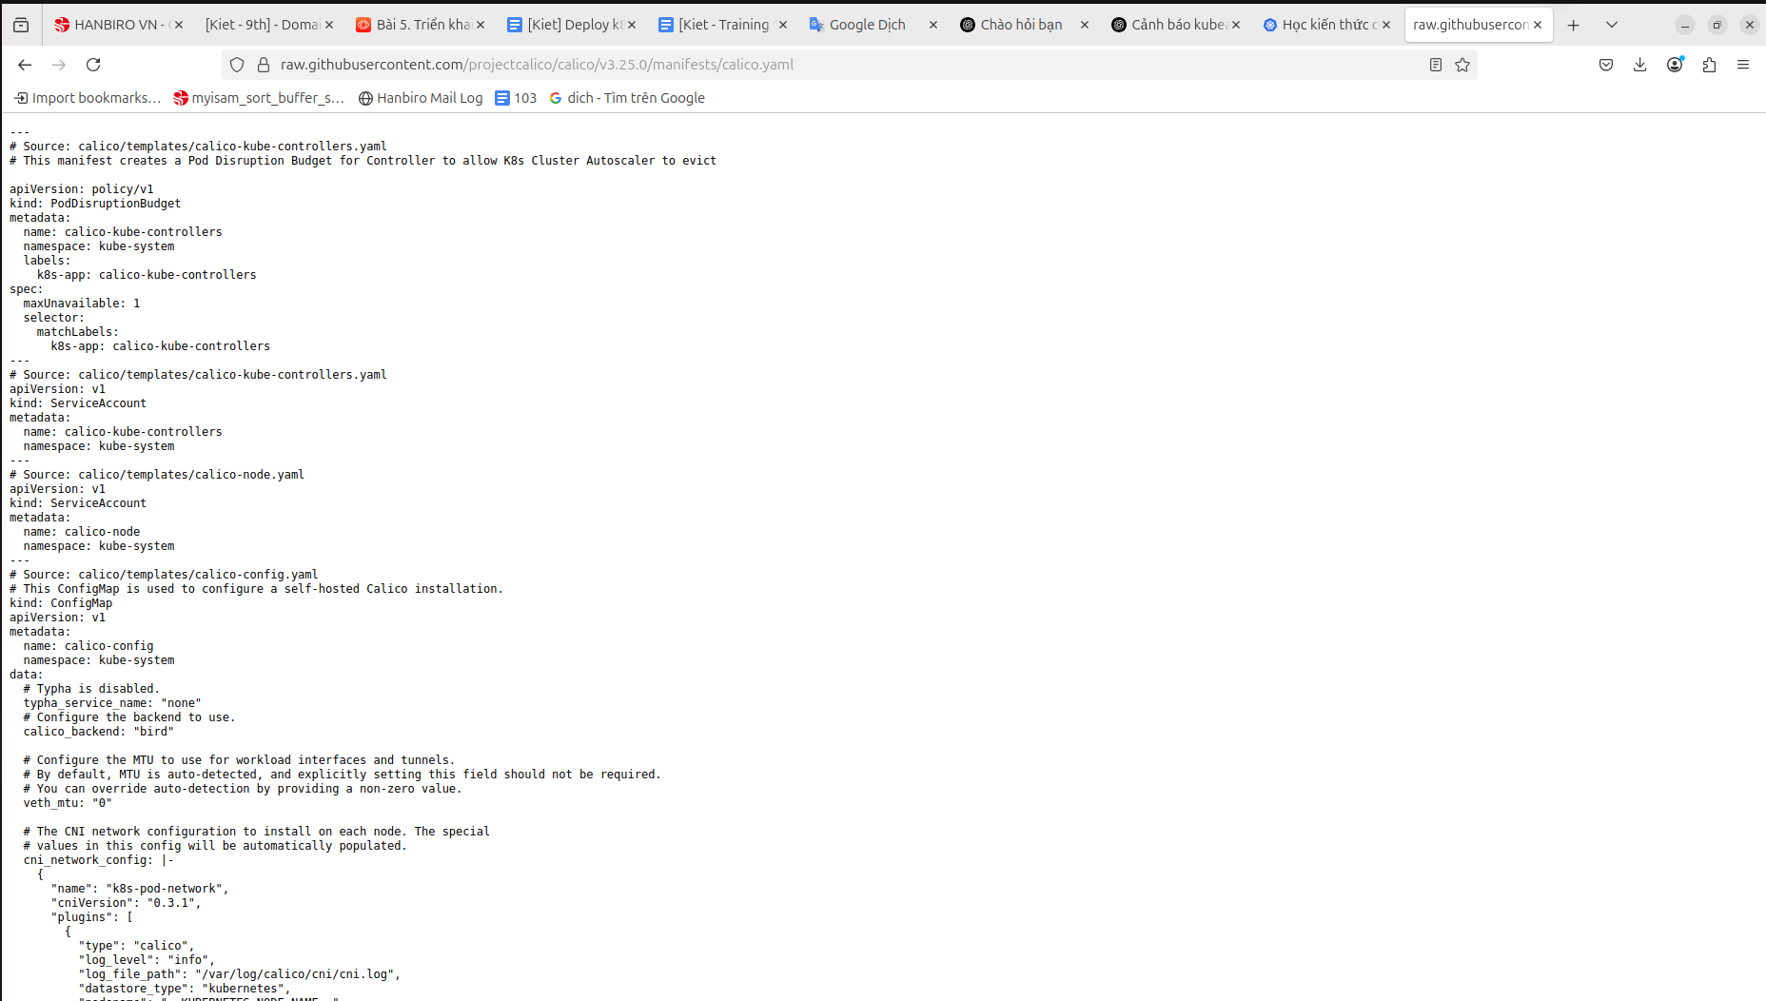

**kubectl apply -f** [**https://raw.githubusercontent.com/projectcalico/calico/v3.25.0/manifests/calico.yaml**](https://raw.githubusercontent.com/projectcalico/calico/v3.25.0/manifests/calico.yaml)

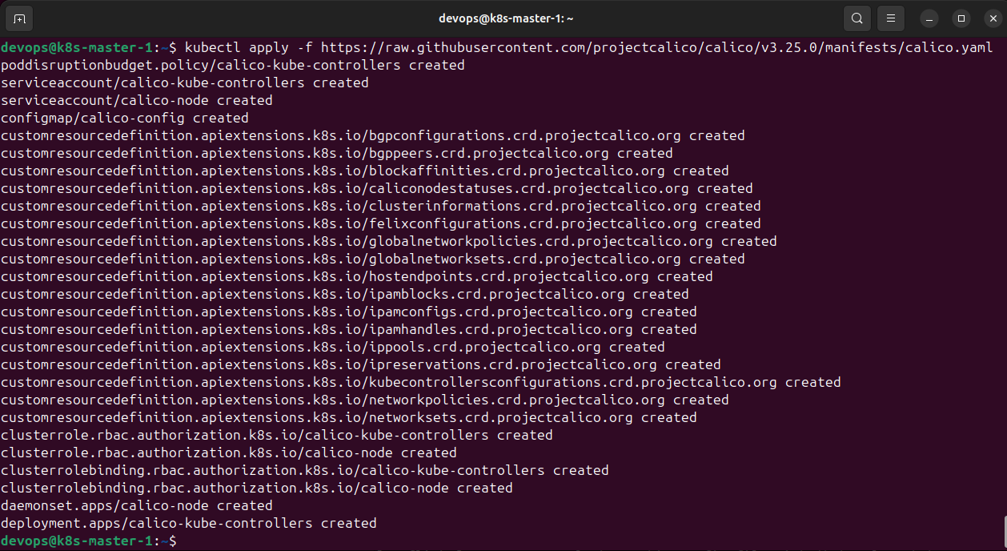

*→ a bunch of resources have been created on the k8s cluster. Kubelet will interact with Calico to create Pod Network Interfaces (PNIs) for each Pod.*

* recheck STATUS nodes on **k8s-master-1**

kubectl get no

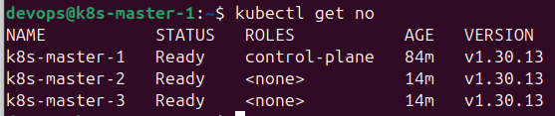

**Change from 1 master + 2 workers model to 3 masters (also workers) model**

* reset cluster (on 3 VMs):

sudo kubeadm reset -f

sudo rm -rf /var/lib/etcd

sudo rm -rf /etc/kubernetes/manifests/*

* init with endpoint and cert (on k8s-master-1):

sudo kubeadm init --control-plane-endpoint "**172.16.146.111**:6443" --upload-certs

mkdir -p $HOME/.kube

sudo cp -i /etc/kubernetes/admin.conf $HOME/.kube/config

sudo chown $(id -u):$(id -g) $HOME/.kube/config

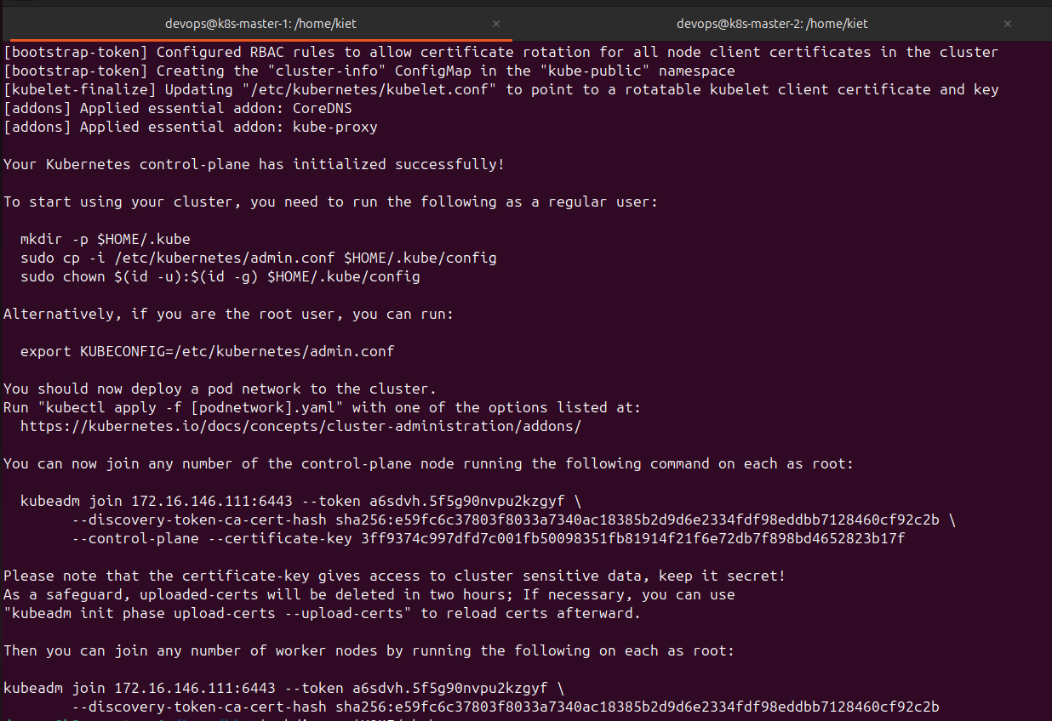

* Run on server k8s-master-2 and k8s-master-3 (use the correct token and cert key that were created in step 1):

**sudo kubeadm join 172.16.146.111:6443 --token a6sdvh.5f5g90nvpu2kzgyf \**

**--discovery-token-ca-cert-hash sha256:e59fc6c37803f8033a7340ac18385b2d9d6e2334fdf98eddbb7128460cf92c2b \**

**--control-plane --certificate-key 3ff9374c997dfd7c001fb50098351fb81914f21f6e72db7f898bd4652823b17f**

mkdir -p $HOME/.kube

sudo cp -i /etc/kubernetes/admin.conf $HOME/.kube/config

sudo chown $(id -u):$(id -g) $HOME/.kube/config

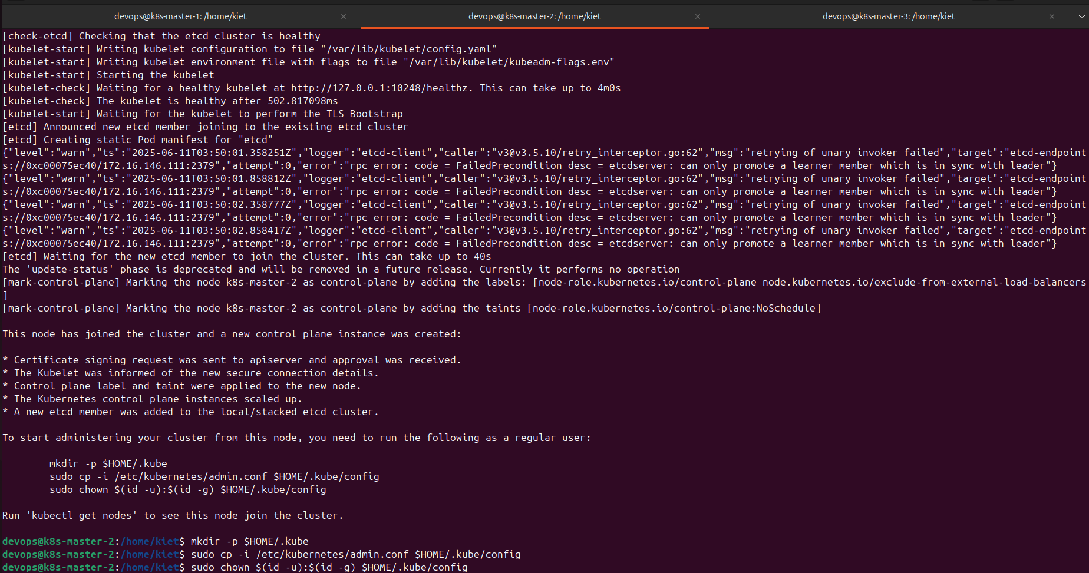

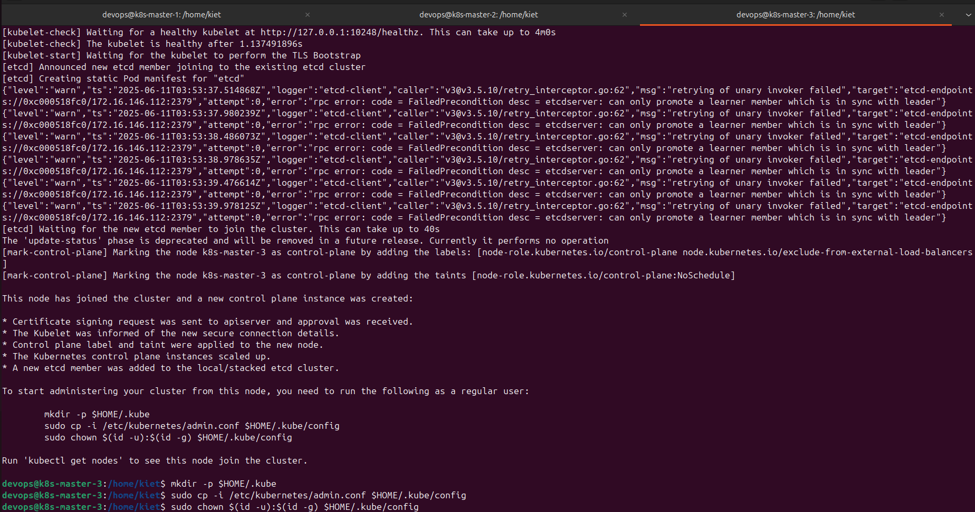

* Specify nodes that can be workers - remove taint to allow master to act as worker (on k8s-master-1):

kubectl taint nodes k8s-master-1 node-role.kubernetes.io/control-plane:NoSchedule-

kubectl taint nodes k8s-master-2 node-role.kubernetes.io/control-plane:NoSchedule-

kubectl taint nodes k8s-master-3 node-role.kubernetes.io/control-plane:NoSchedule-

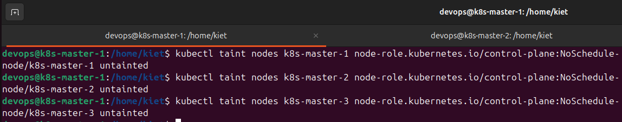

* check nodes:

kubectl get no

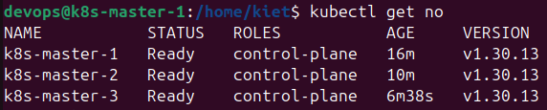

**Install and Configure Elasticsearch**

* create and apply StorageClass - k8s needs StorageClass to manage volumes for pods, use local-path-provisioner to create local volumes (on local disk):

sudo nano storageclass-local.yaml

==================================

apiVersion: storage.k8s.io/v1

kind: StorageClass

metadata:

name: local-path

provisioner: rancher.io/local-path

reclaimPolicy: Delete

volumeBindingMode: WaitForFirstConsumer

==================================

* apply StorageClass local yaml file:

kubectl apply -f storageclass-local.yaml

* download local-path-provisioner:

kubectl apply -f https://raw.githubusercontent.com/rancher/local-path-provisioner/master/deploy/local-path-storage.yaml

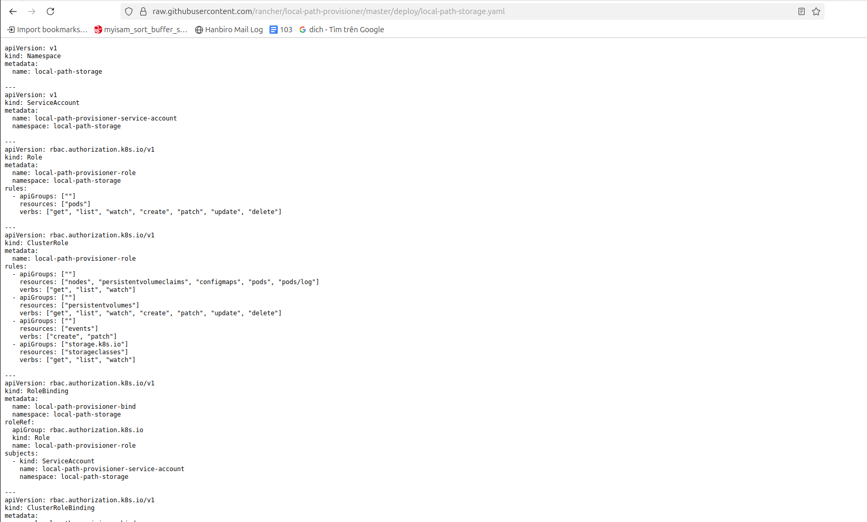

*\*\*\* note:*

By default, it will create a Pod to handle PVC → PV creation on the local node:

* PV (PersistentVolume): is a storage drive created in the cluster (created by the admin or the system)
* PVC (PersistentVolumeClaim): is a request to use that drive (created by the user)
* download Helm & add Elasticsearch Helm Repo:

curl https://raw.githubusercontent.com/helm/helm/main/scripts/get-helm-3 | bash

helm repo add elastic https://helm.elastic.co

helm repo update

* install Elasticsearch with values.yaml file:

sudo nano values.yaml

=============================

replicas: 3

esJavaOpts: "-Xms512m -Xmx512m"

resources:

requests:

cpu: "500m"

memory: "1Gi"

limits:

cpu: "1"

memory: "1Gi"

volumeClaimTemplate:

accessModes: ["ReadWriteOnce"]

resources:

requests:

storage: 10Gi

storageClassName: local-path

network:

host: "0.0.0.0"

=============================

*→ This configuration initializes 3 Elasticsearch pods with 10Gi volume, using StorageClass local-path*

* install elasticsearch with helm and values.yaml file:

helm install elasticsearch elastic/elasticsearch -f values.yaml

* check Elasticsearch status:

kubectl get pods -l app=elasticsearch-master

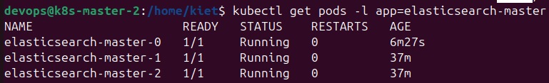

kubectl get svc -l app=elasticsearch-master



* more details:

kubectl describe pod -l app=elasticsearch-master

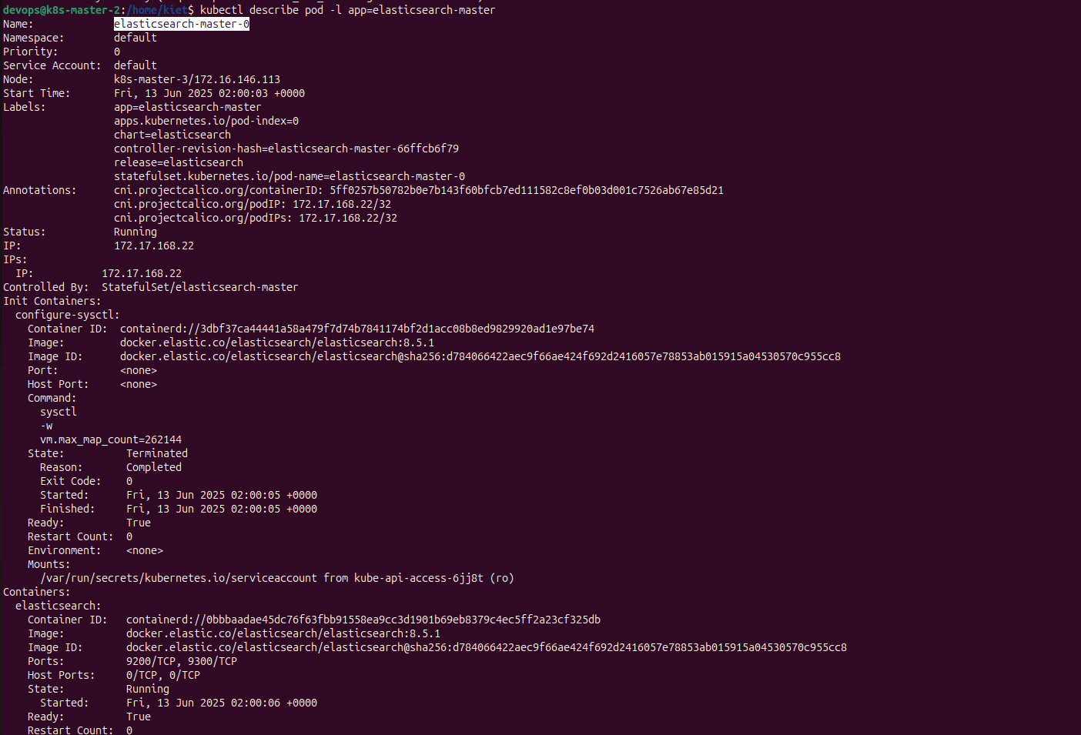

**. . . . . . . . . . . .**

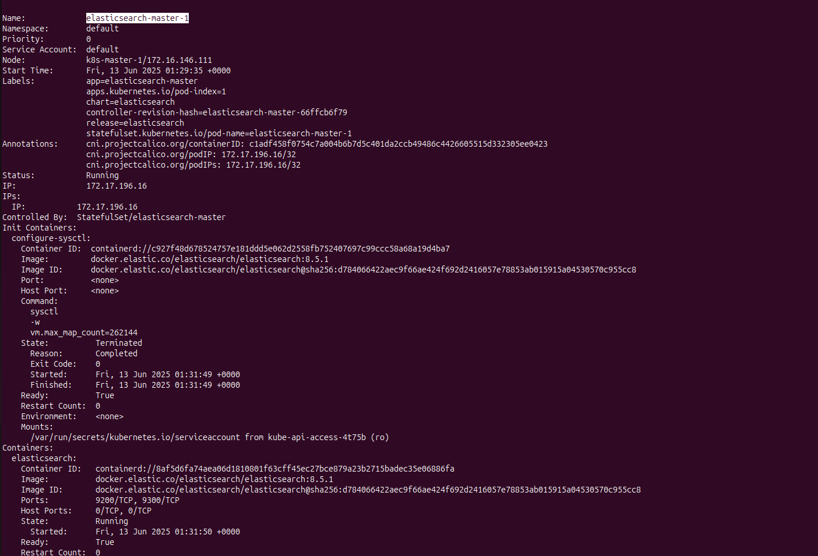

**. . . . . . . . . . . .**

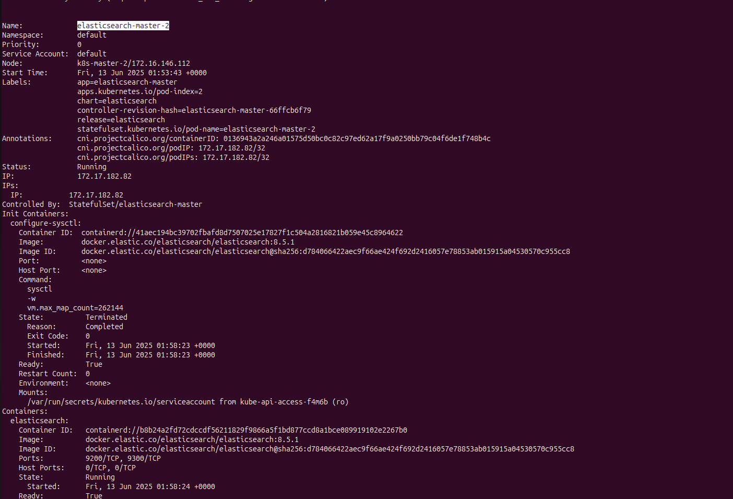

**. . . . . . . . . . . .**

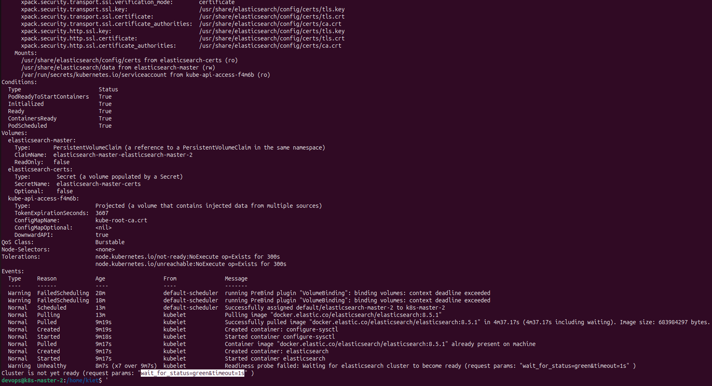

* Check Secret contains password elastic (verify with key password):

kubectl get secret | grep elastic

kubectl get secret elasticsearch-master-credentials -o yaml

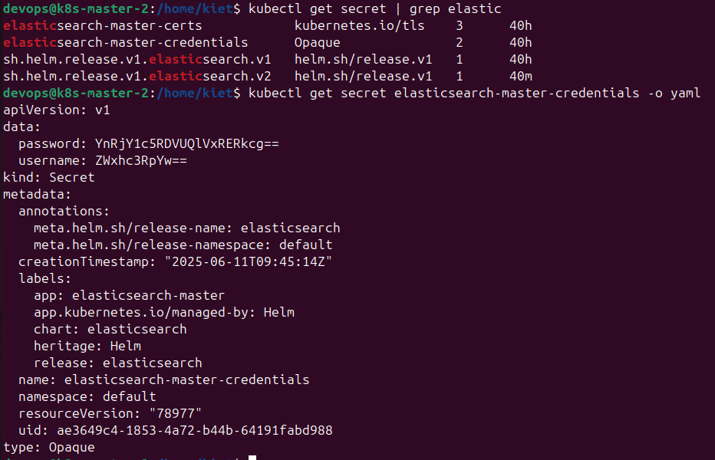

* Verify that you have the key password. Then, to get the password:

kubectl get secret elasticsearch-master-credentials -o jsonpath="{.data.password}" | base64 -d



→ pass: **btccW9D5TBUqDDdr**

* check directly in **elasticsearch-master** pods:

kubectl exec -it **elasticsearch-master-0** -- curl -k -u **elastic:btccW9D5TBUqDDdr** https://localhost:9200

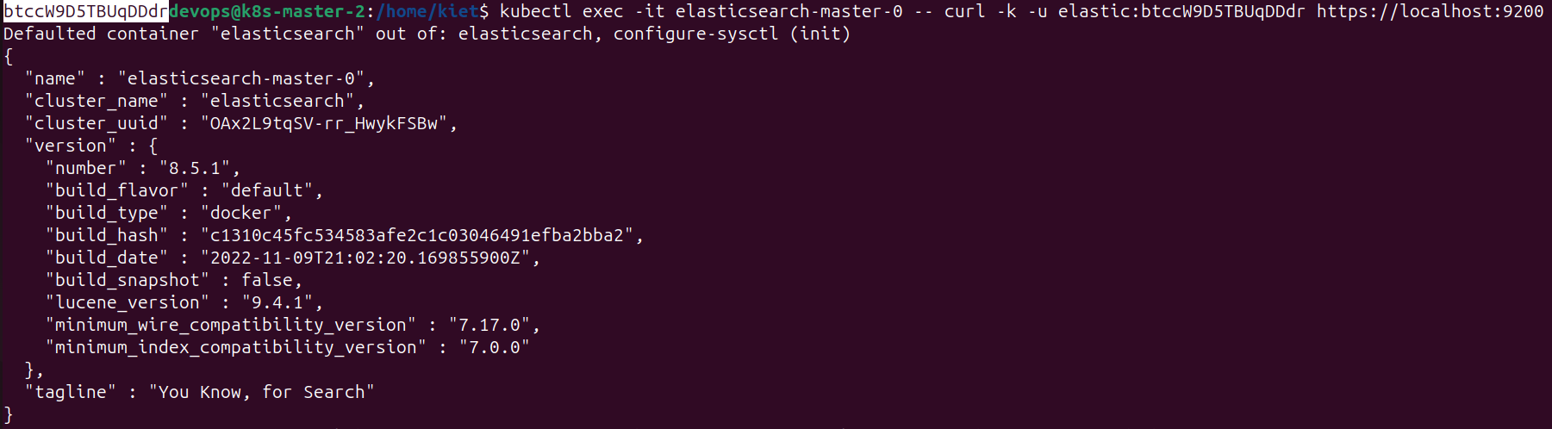

kubectl exec -it **elasticsearch-master-1** -- curl -k -u **elastic:btccW9D5TBUqDDdr** https://localhost:9200

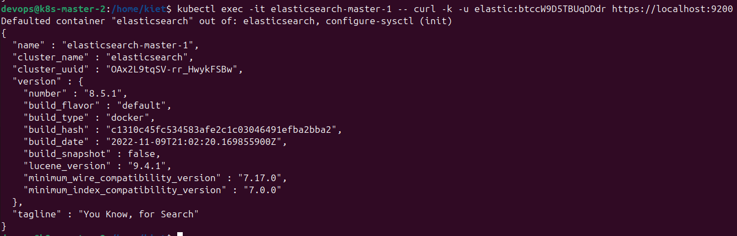

kubectl exec -it **elasticsearch-master-2** -- curl -k -u **elastic:btccW9D5TBUqDDdr** https://localhost:9200

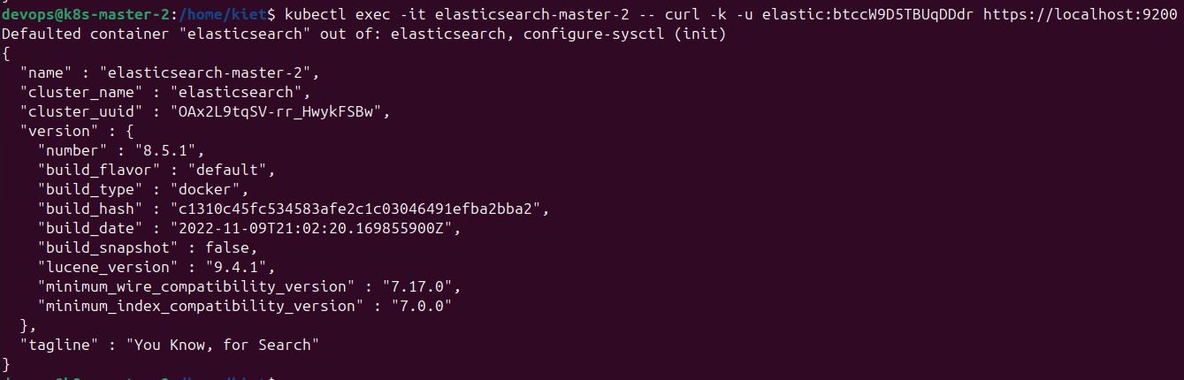

* check cluster status:

kubectl exec -it **elasticsearch-master-0** -- curl -k -u **elastic:btccW9D5TBUqDDdr** https://localhost:9200/_cluster/health?pretty

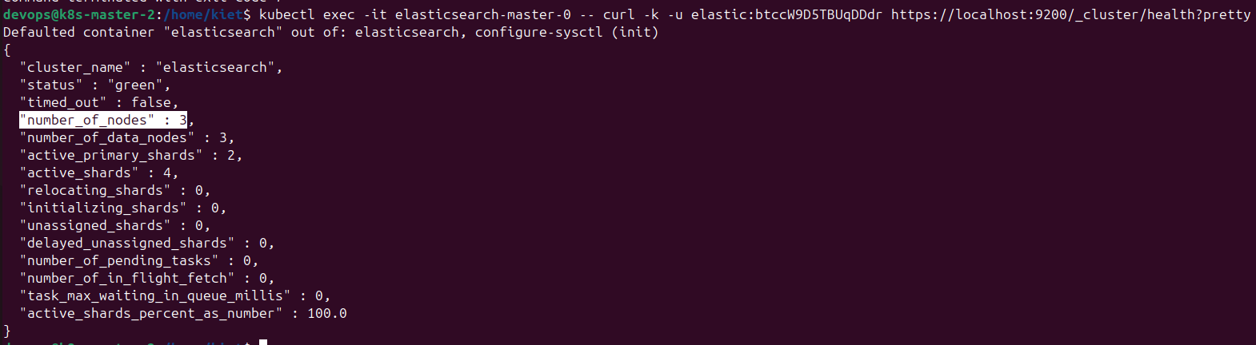

kubectl exec -it **elasticsearch-master-1** -- curl -k -u **elastic:btccW9D5TBUqDDdr** https://localhost:9200/_cluster/health?pretty

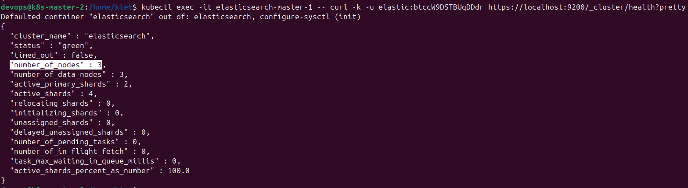

kubectl exec -it **elasticsearch-master-2** -- curl -k -u **elastic:btccW9D5TBUqDDdr** https://localhost:9200/_cluster/health?pretty

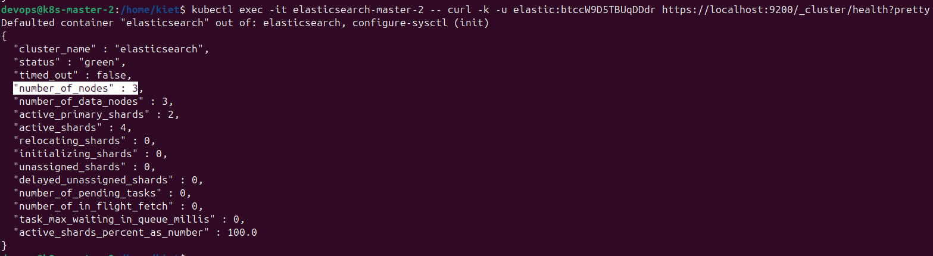

* expose Elasticsearch according to NodePort:

kubectl edit svc elasticsearch-master

type: **ClusterIP** → type: **NodePort**



kubectl get svc elasticsearch-master (check port auto generate: **30715**)



* check pods:

kubectl get pods -o wide --all-namespaces

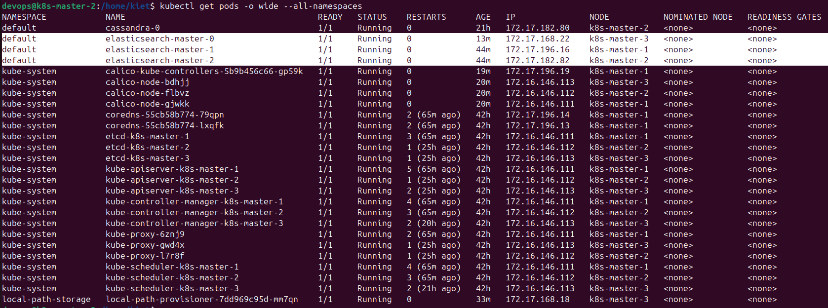

* access to [https://172.16.146**.113:**](https://172.16.146.113:32532/)**30715**[**/**](https://172.16.146.113:32532/) (**.111** or **.112** worked) on browser with:

+ username: **elastic**

+ password: **btccW9D5TBUqDDdr**

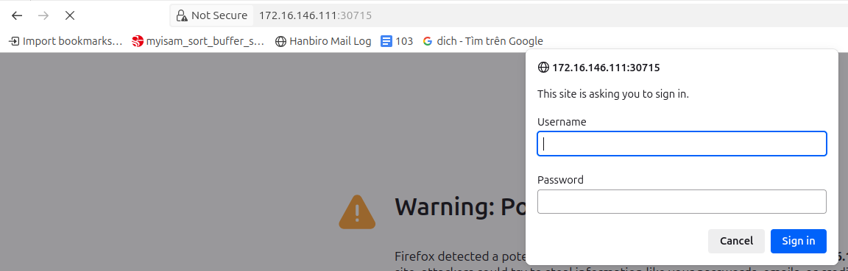

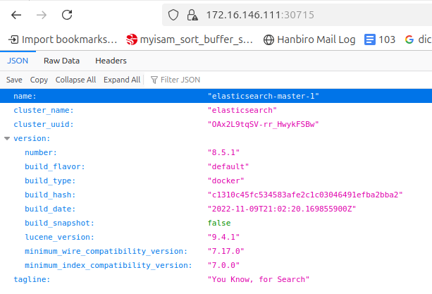

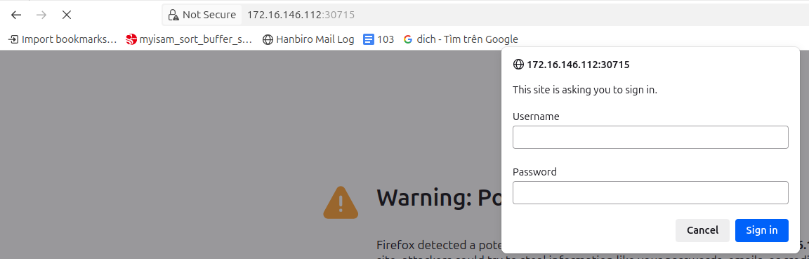

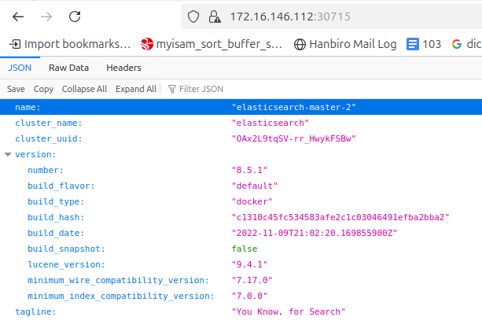

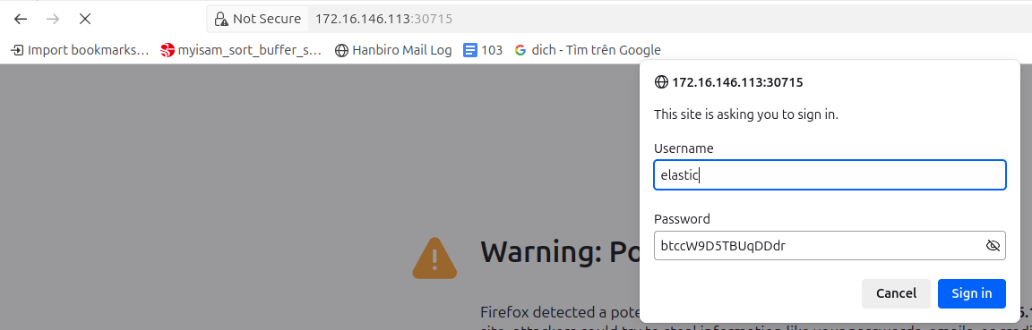

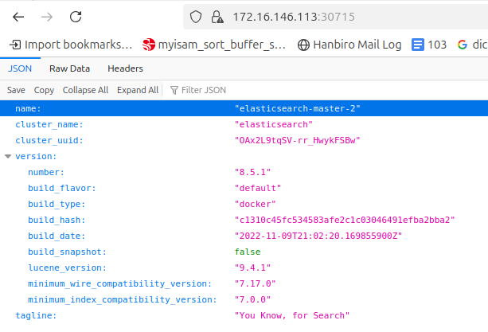

***[ Test CRUD and check data ]***

* **insert** data into elasticsearch at **113**:

curl -k -u elastic:**btccW9D5TBUqDDdr** -X **POST** https://172.16.146.**113:30715**/**my-index/_doc/1** \

-H "Content-Type: application/json" \

-d '{"message": "**Hello Elasticsearch!**"}'



* check data at **113** after inserted data:

***kubectl exec -it elasticsearch-master-0|1|2 --*** curl -k -u elastic:**btccW9D5TBUqDDdr** https://172.16.146.**113**:**30715**/my-index/_search?pretty

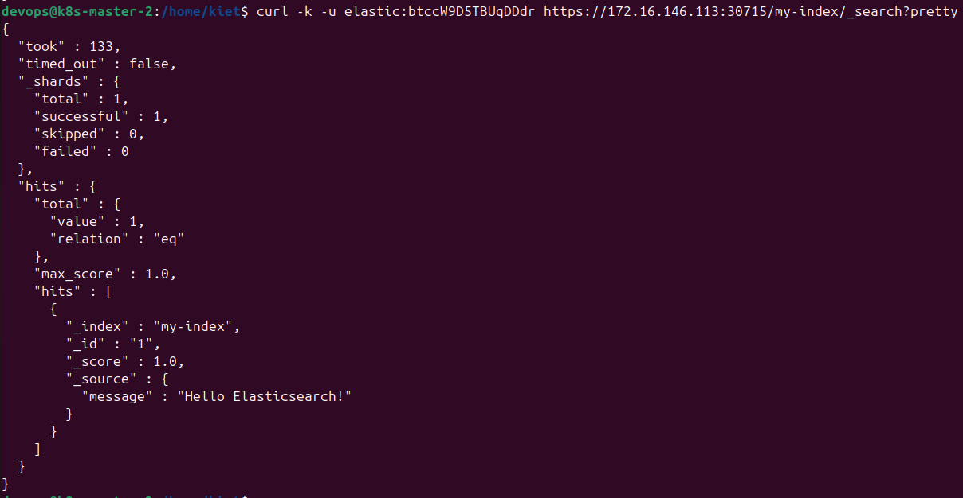

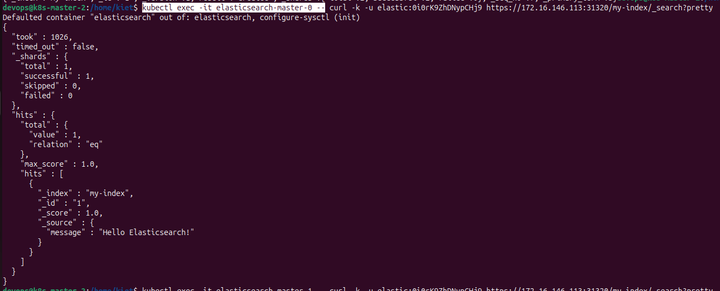

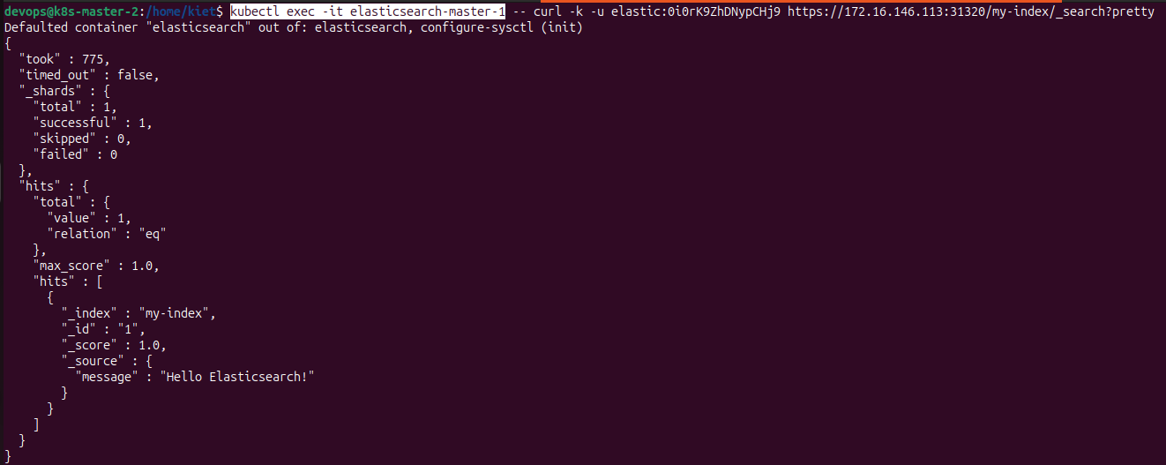

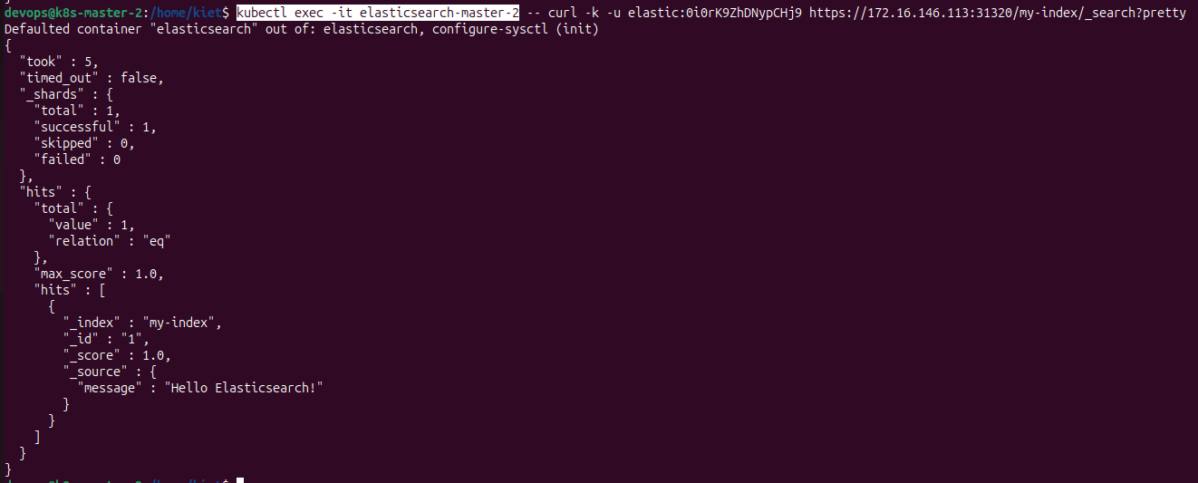

**==>** check at **112** after inserted data:

***kubectl exec -it elasticsearch-master-0|1|2*** curl -k -u elastic:**btccW9D5TBUqDDdr** https://172.16.146.**112**:**30715**/my-index/_search?pretty

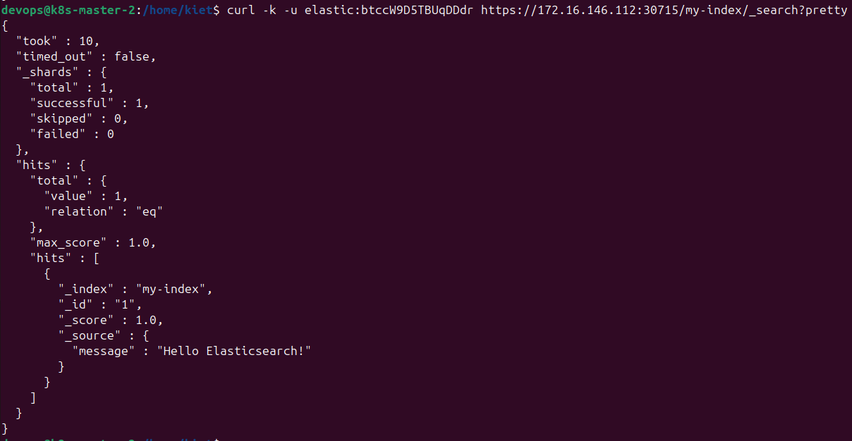

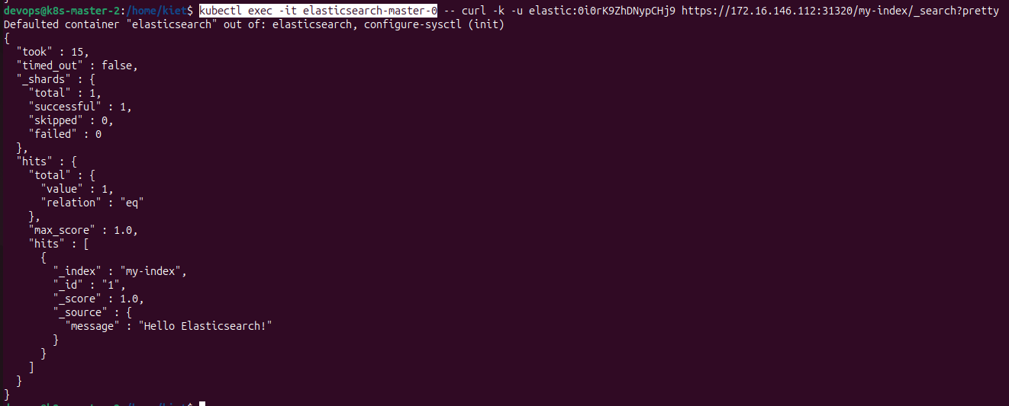

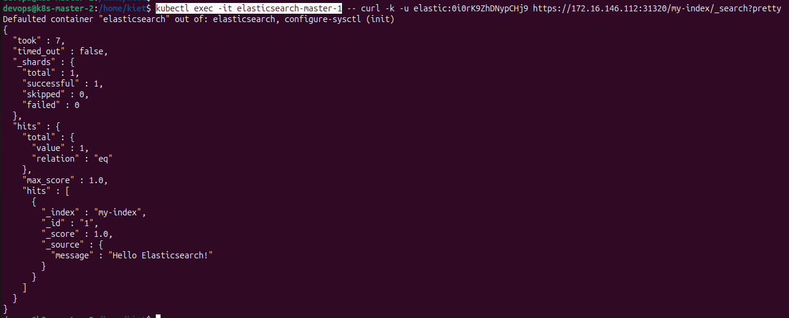

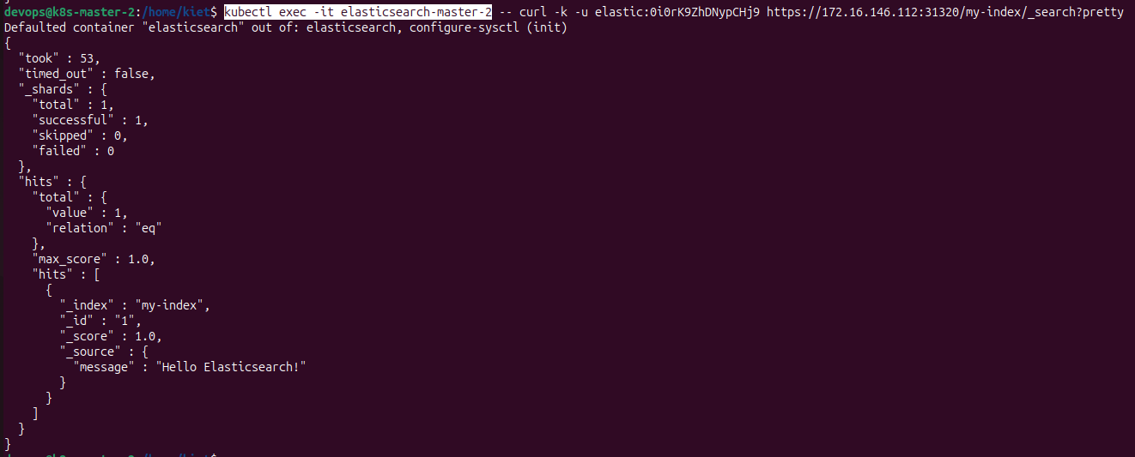

**==>** check at **111** after inserted data:

***kubectl exec -it elasticsearch-master-0|1|2*** curl -k -u elastic:**btccW9D5TBUqDDdr** https://172.16.146.**111**:**30715**/my-index/_search?pretty

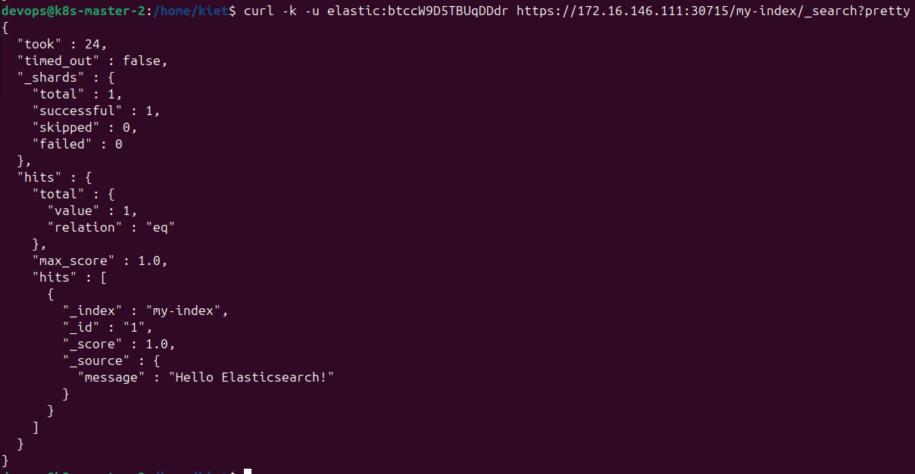

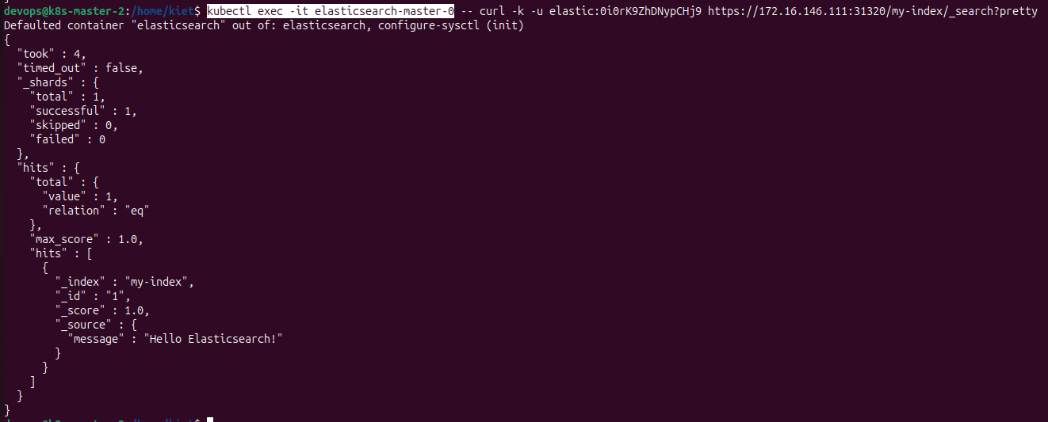

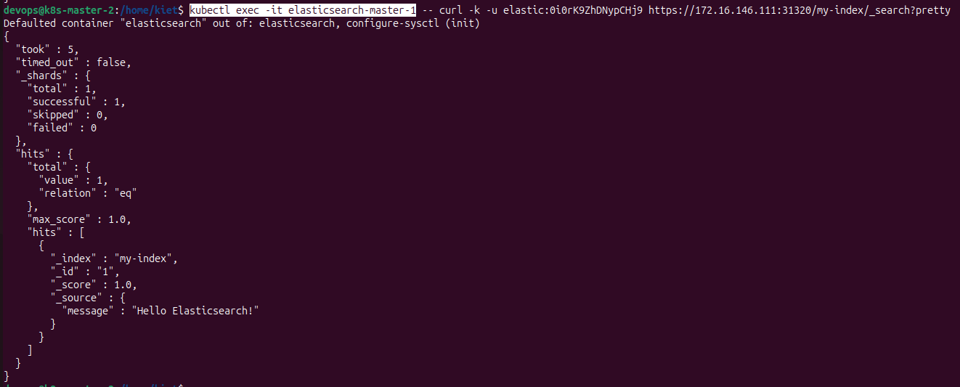

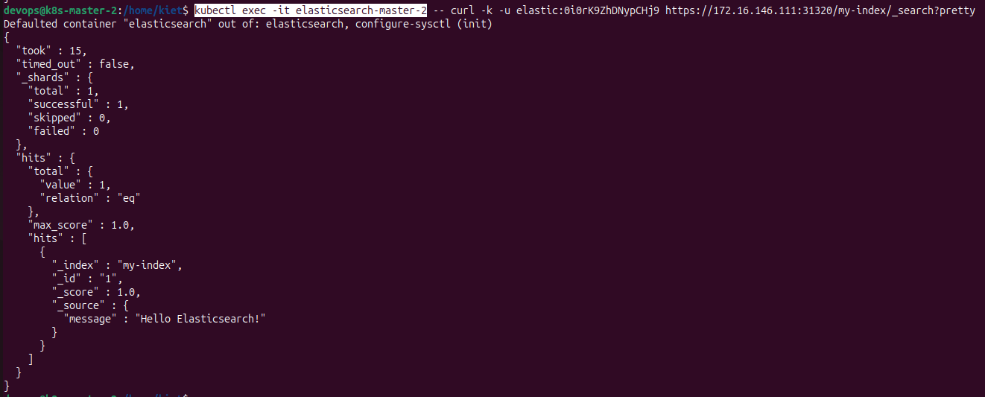

* **update** data by **id** at **111**:

curl -k -u elastic:**btccW9D5TBUqDDdr** -X **PUT** https://172.16.146.**111**:**30715**/my-index/_doc/**1** \

-H "Content-Type: application/json" \

-d '{"message": "**Updated message!**"}'

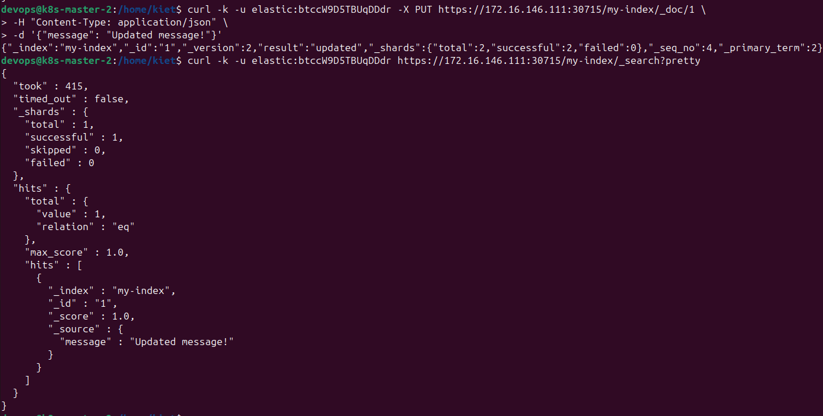

# tested + checked for each pod: ***kubectl exec -it elasticsearch-master-0|1|2***

**==>** check at **112** after updated data**:**

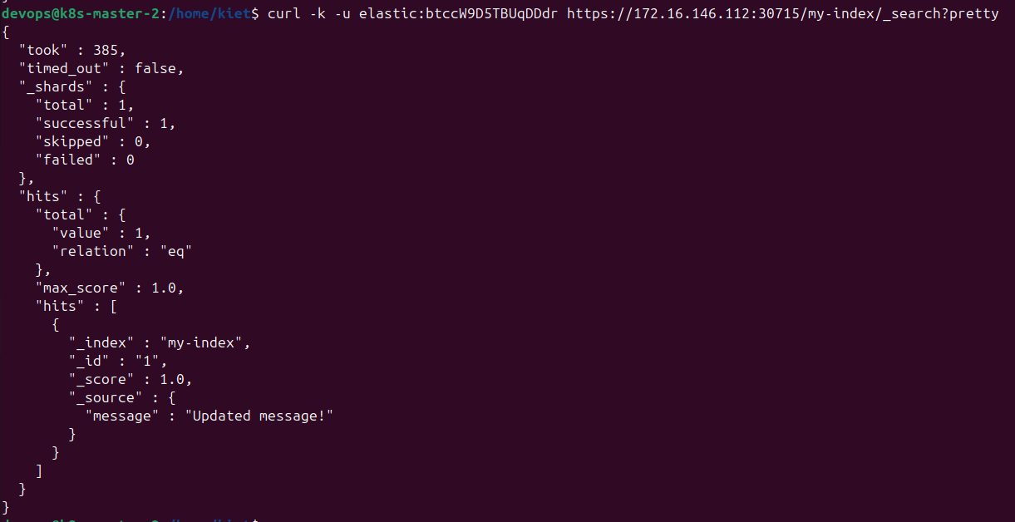

# tested + checked for each pod: ***kubectl exec -it elasticsearch-master-0|1|2***

**==>** check at **113** after updated data**:**

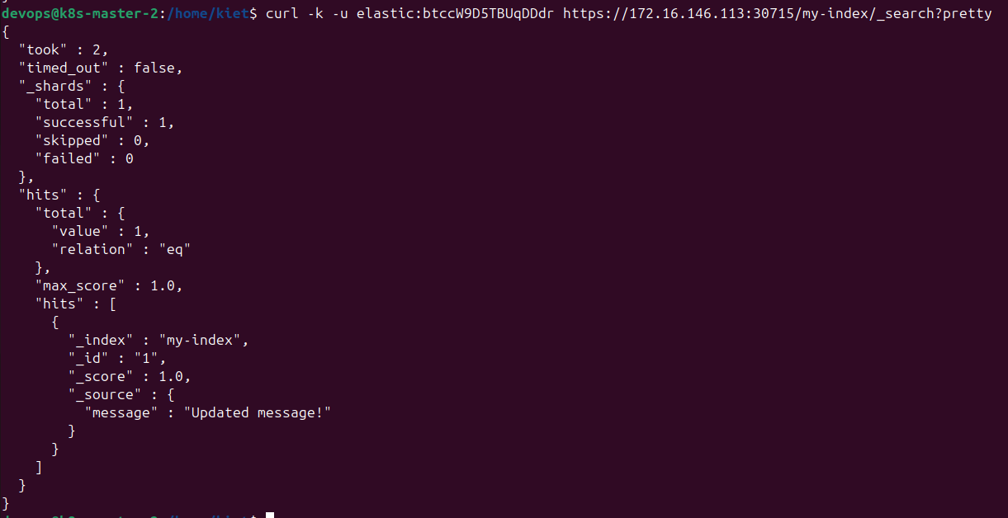

# tested + checked for each pod: ***kubectl exec -it elasticsearch-master-0|1|2***

* **delete** data by **id** at **112**:

curl -k -u elastic:**btccW9D5TBUqDDdr** -X **DELETE** https://172.16.146.**112**:**30715**/my-index/_doc/**1**

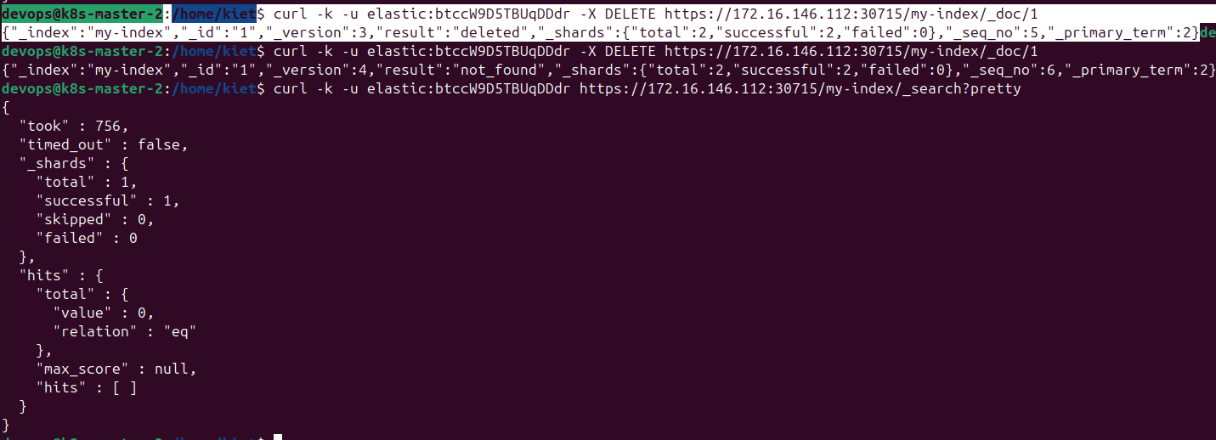

# tested + checked for each pod: ***kubectl exec -it elasticsearch-master-0|1|2***

**==>** check at **111** after deleted data**:**

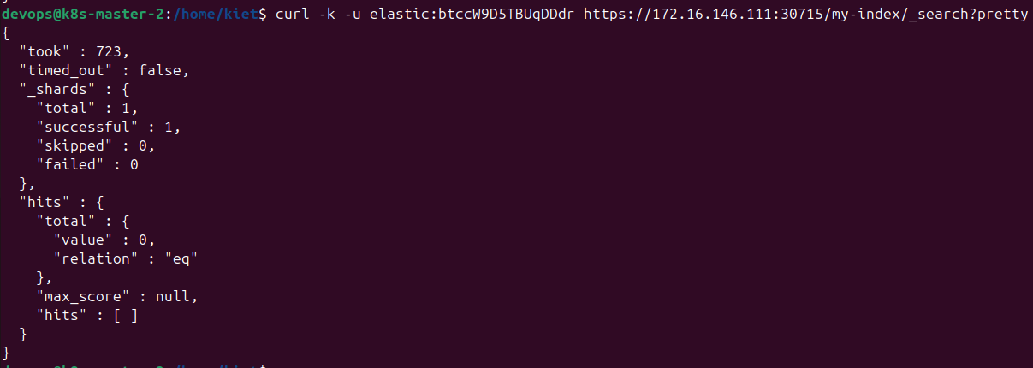

# tested + checked for each pod: ***kubectl exec -it elasticsearch-master-0|1|2***

**==>** check at **113** after deleted data**:**

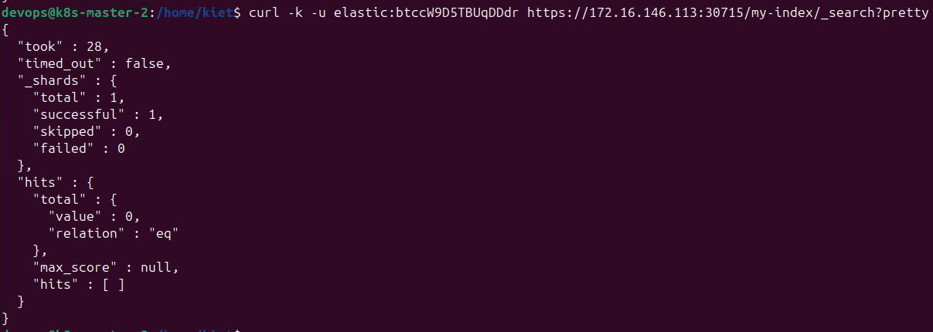

# tested + checked for each pod: ***kubectl exec -it elasticsearch-master-0|1|2***

* Check node informations in Elasticsearch cluster:

curl -k -u elastic:**btccW9D5TBUqDDdr** https://172.16.146.**111:30715**/_cat/nodes?v=true

curl -k -u elastic:**btccW9D5TBUqDDdr** https://172.16.146.**112:30715**/_cat/nodes?v=true

curl -k -u elastic:**btccW9D5TBUqDDdr** https://172.16.146.**113:30715**/_cat/nodes?v=true

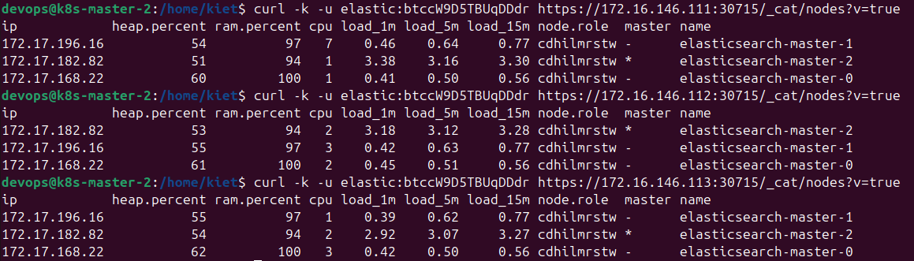

**Install and Configure Cassandra**

* Add Bitnami Helm Repo:

helm repo add bitnami https://charts.bitnami.com/bitnami

helm repo update

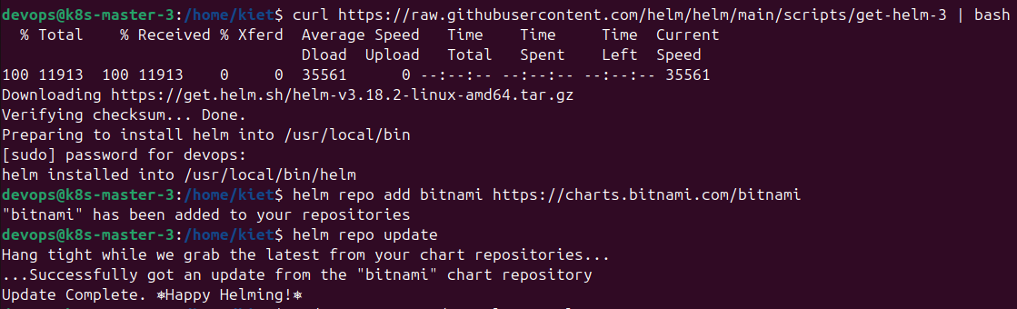

* create a custom values.yaml file to control Cassandra configuration, including CPU, RAM, number of replicas, volume,…

sudo nano cassandra-values.yaml

=====================

replicaCount: 3

image:

tag: 4.1.3

resources:

requests:

memory: "512Mi"

cpu: "500m"

limits:

memory: "1Gi"

cpu: "1"

persistence:

enabled: true

storageClass: local-path

accessModes:

- ReadWriteOnce

size: 10Gi

=====================

*\*\*\* note:*

* **replicaCount: 3** : create 3 Cassandra nodes for cluster
* **persistence.enabled: true** : data will be saved to hard drive
* **storageClass: local-path** : use installed StorageClass
* install Cassandra via Helm and cassandra values yaml file:

helm install cassandra bitnami/cassandra -f cassandra-values.yaml

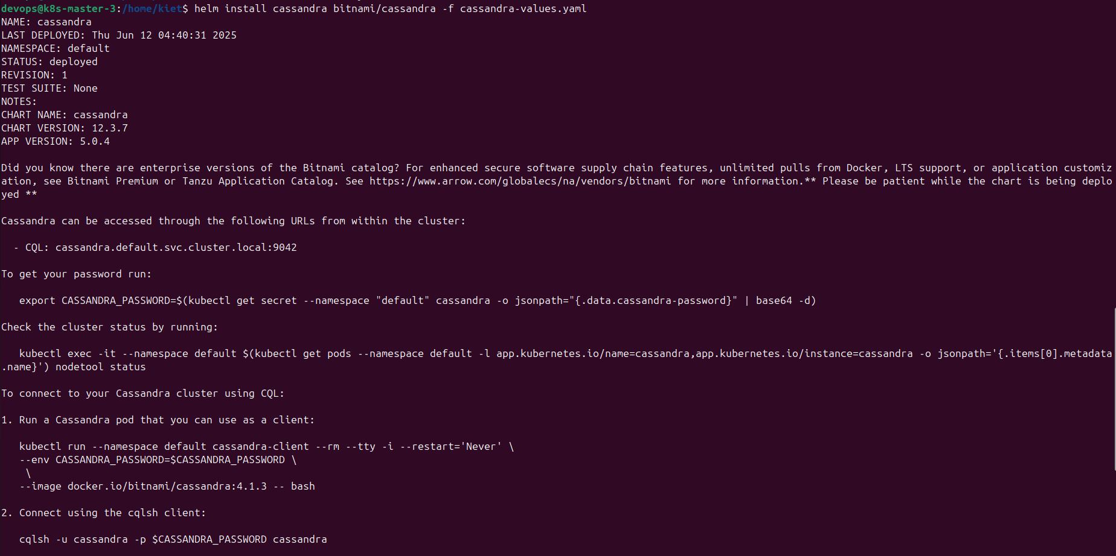

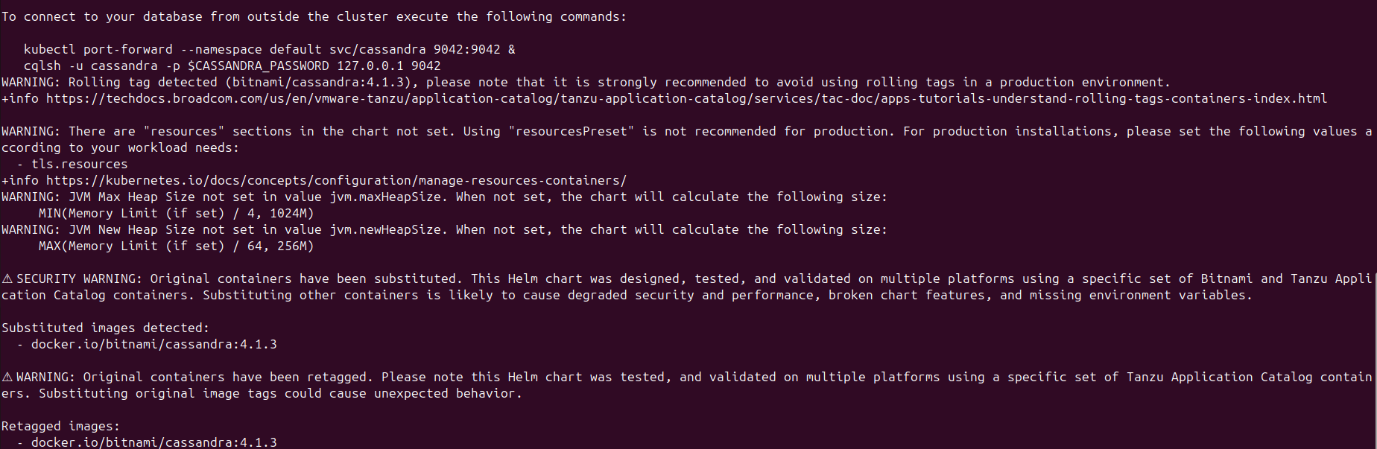

* check READY and STATUS of Cassandra pods:

kubectl get pods -l app.kubernetes.io/name=cassandra

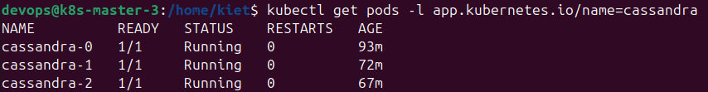

* check status cluster Cassandra:

kubectl exec -it cassandra-0 -- nodetool status

kubectl exec -it cassandra-1 -- nodetool status

kubectl exec -it cassandra-2 -- nodetool status

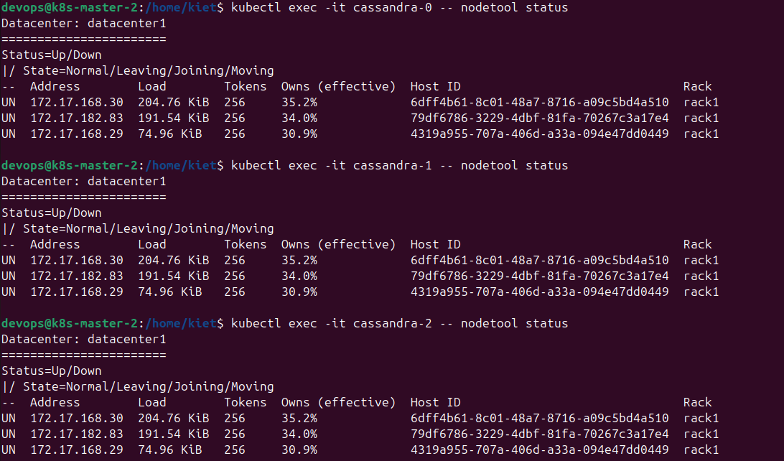

*\*\*\* note:* **UN** means **Up & Normal** **→ Cluster is stable**. If you see UJ, DN, or UL, there may be pods that have not finished syncing.

* Check if there is any Secret containing auth information. And Find secret with related name **cassandra**:

kubectl get secrets

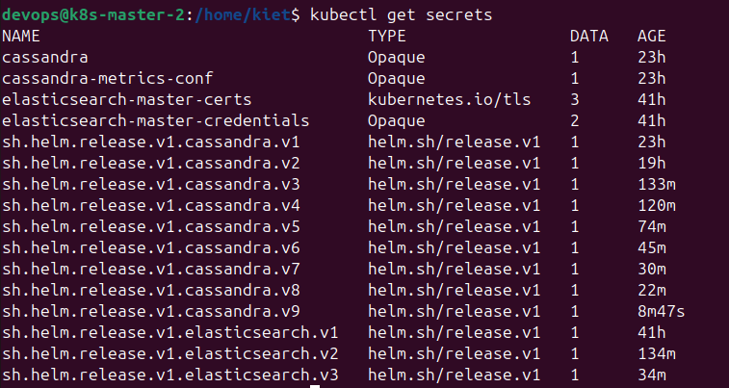

kubectl get secret cassandra

kubectl get secret cassandra -o yaml

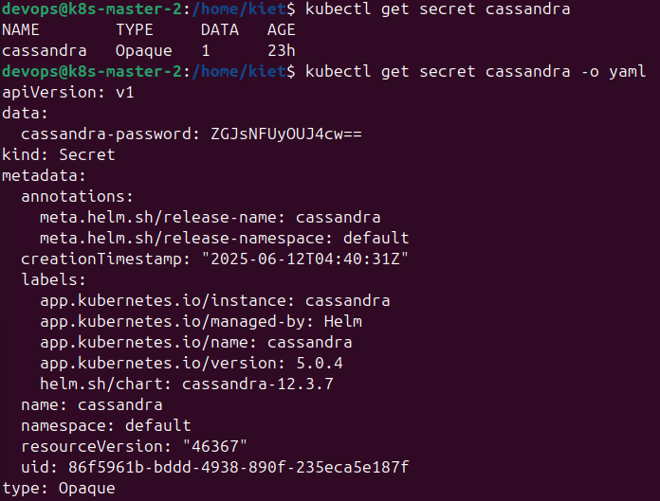

* check password user **cassandra** and access into **cqlsh**:

kubectl get secret cassandra -o jsonpath="{.data.cassandra-password}" | base64 --decode; echo

→ **dbl4U29Bxs**



**[ Test CRUD via cqlsh and check sync between 3 pods cassandra-0|1|2 ]**

* access cqlsh via **cassandra-0** pod:

kubectl exec -it **cassandra-0** -- cqlsh -u **cassandra** -p **dbl4U29Bxs**

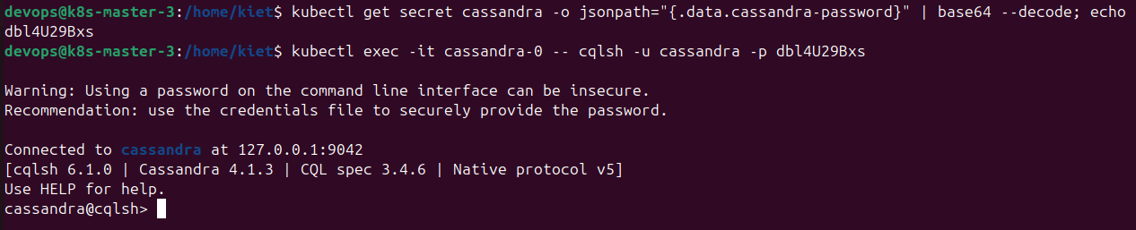

* **create Keyspace:**

CREATE KEYSPACE IF NOT EXISTS **mykeyspace**

WITH replication = {'class': 'SimpleStrategy', 'replication_factor': 1};

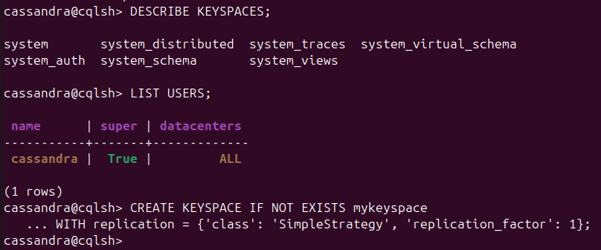

*\*\*\* with:*

* **SimpleStrategy**  -> simple replication for dev environments
* **replication_factor: 1** -> only keep a single copy per node
* **Create table** at **cassandra-0** pod:

USE mykeyspace;

CREATE TABLE IF NOT EXISTS users (

id UUID PRIMARY KEY,

name TEXT,

email TEXT

);

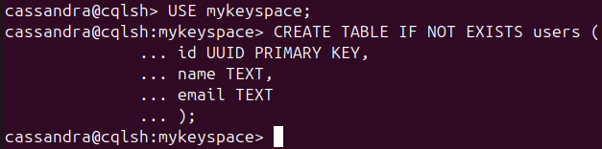

* **Create – Read** data at **cassandra-0** pod:

INSERT INTO users (id, name, email) VALUES (uuid(), 'Kiệt', 'kiet@example.com');

SELECT * FROM users;

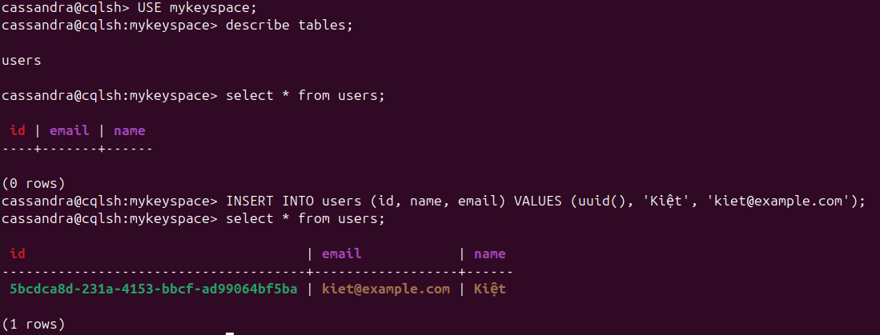

**==>** check at **cassandra-1** podafter created data:

kubectl exec -it **cassandra-1** -- cqlsh -u **cassandra** -p **dbl4U29Bxs**

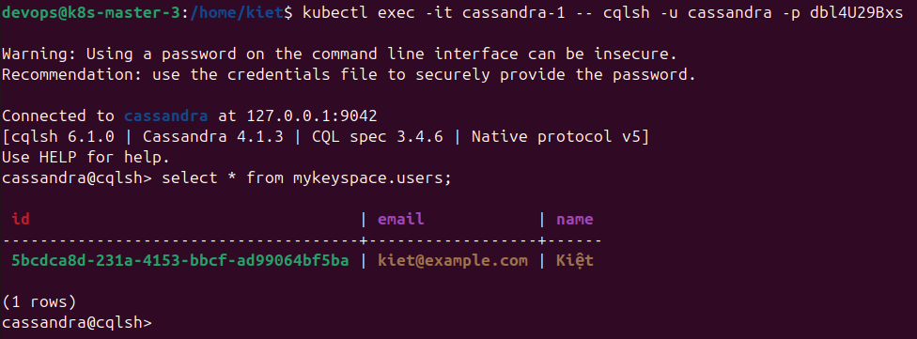

**==>** check at **cassandra-2** pod after created data:

kubectl exec -it **cassandra-2** -- cqlsh -u **cassandra** -p **dbl4U29Bxs**

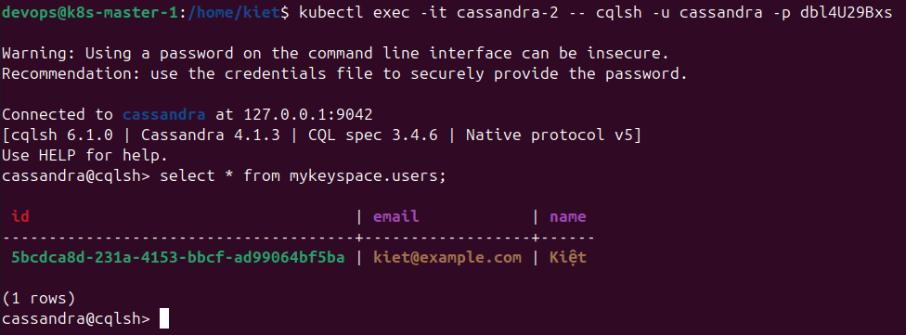

* **Update** data at **cassandra-1** pod:

UPDATE users SET email = 'kiet@newdomain.com' WHERE id = **5bcdca8d-231a-4153-bbcf-ad99064bf5ba**;

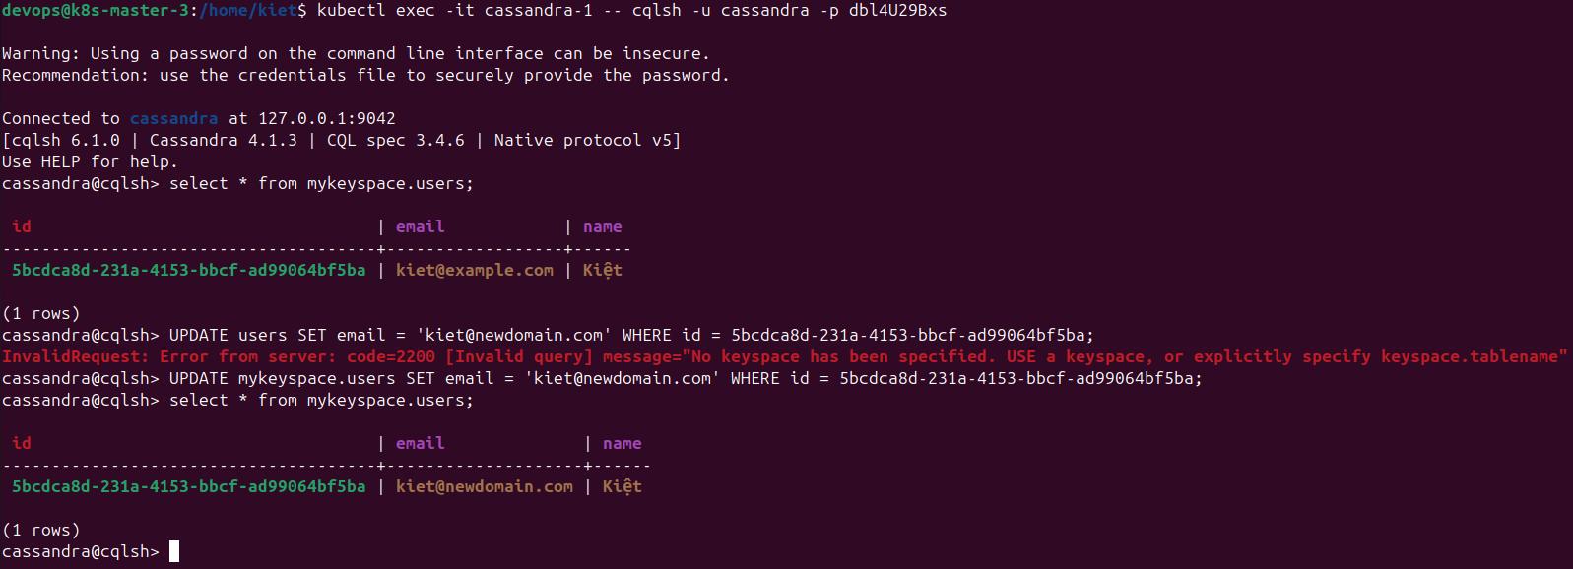

**==>** check at **cassandra-0** pod after updated data:

kubectl exec -it **cassandra-0** -- cqlsh -u **cassandra** -p **dbl4U29Bxs**

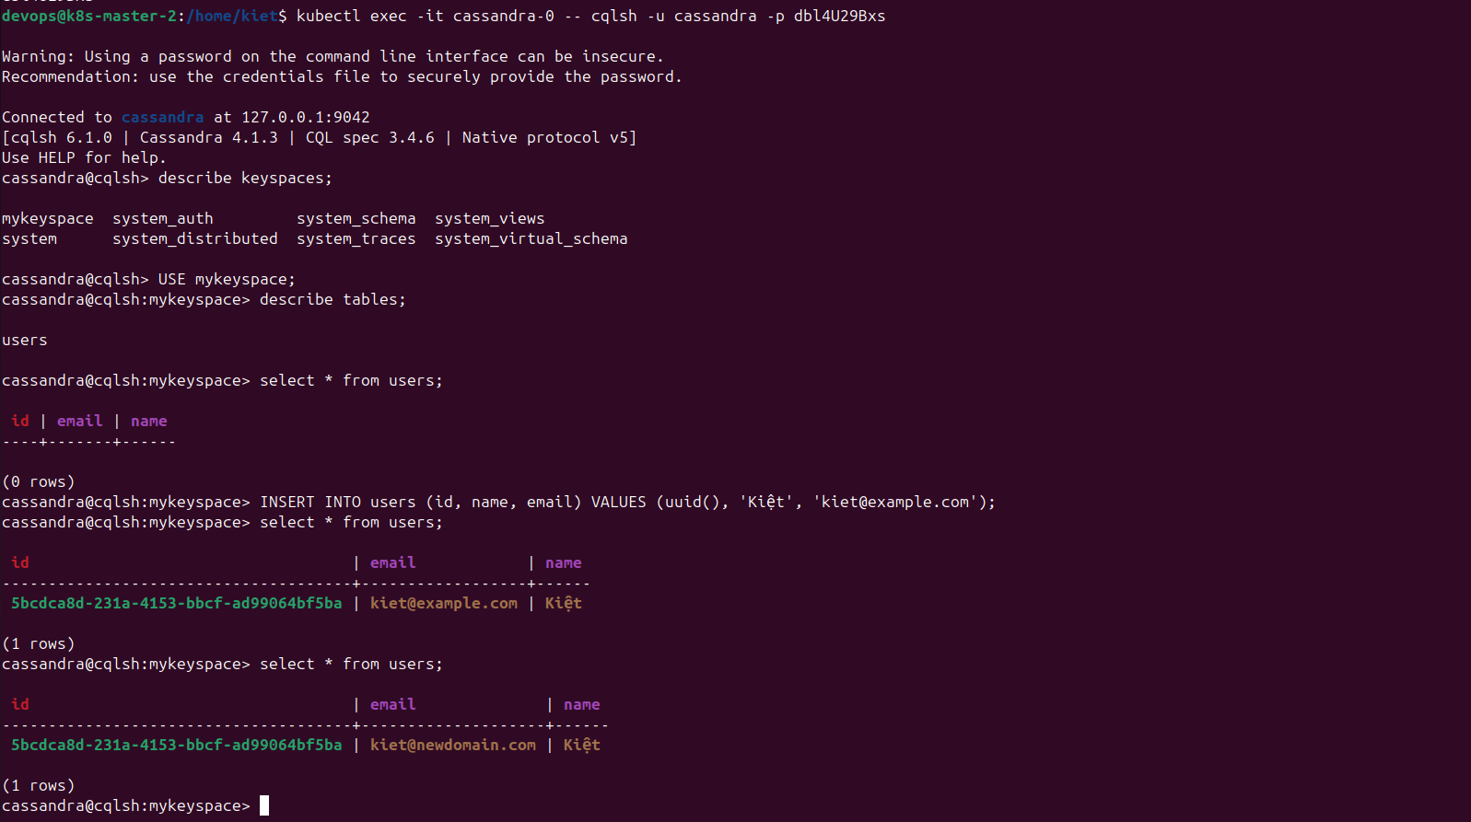

**==>** check at **cassandra-2** podafter updated data:

kubectl exec -it **cassandra-2** -- cqlsh -u **cassandra** -p **dbl4U29Bxs**

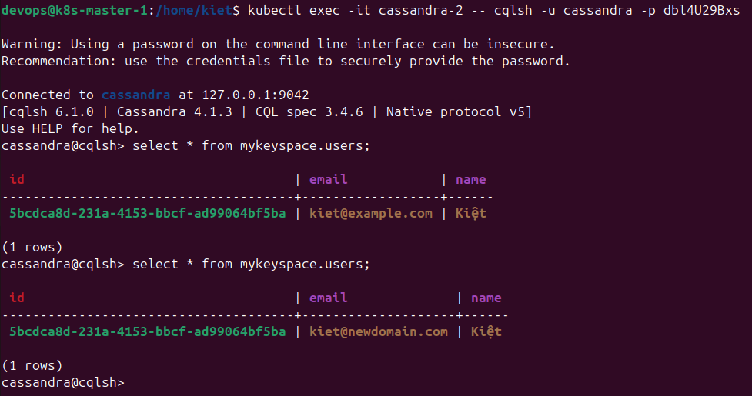

* **Delete** data at **cassandra-2** pod:

DELETE FROM users WHERE id = **5bcdca8d-231a-4153-bbcf-ad99064bf5ba**;

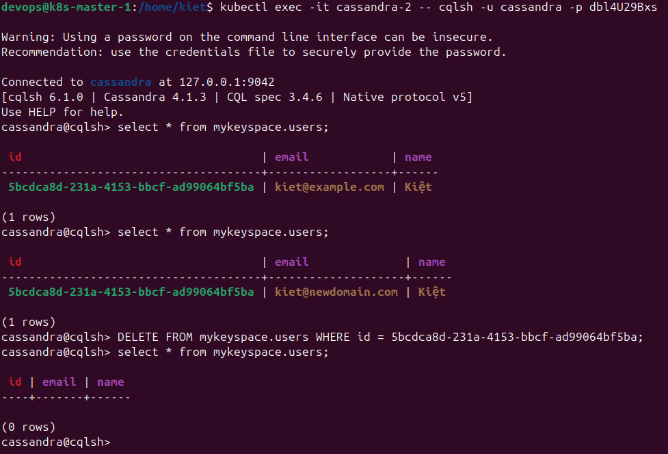

**==>** check at **cassandra-0** podafter deleted data:

kubectl exec -it **cassandra-0** -- cqlsh -u **cassandra** -p **dbl4U29Bxs**

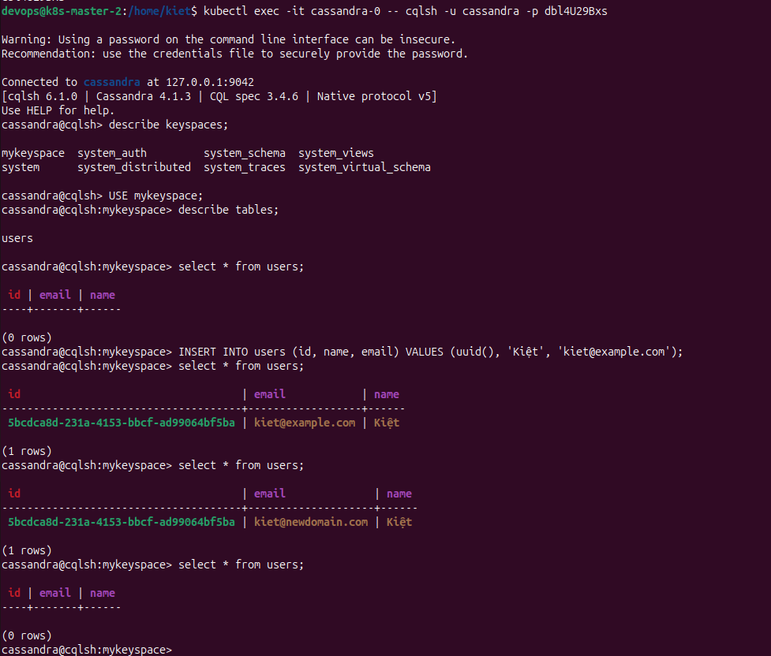

**==>** check at **cassandra-1** pod after deleted data:

kubectl exec -it **cassandra-1** -- cqlsh -u **cassandra** -p **dbl4U29Bxs**

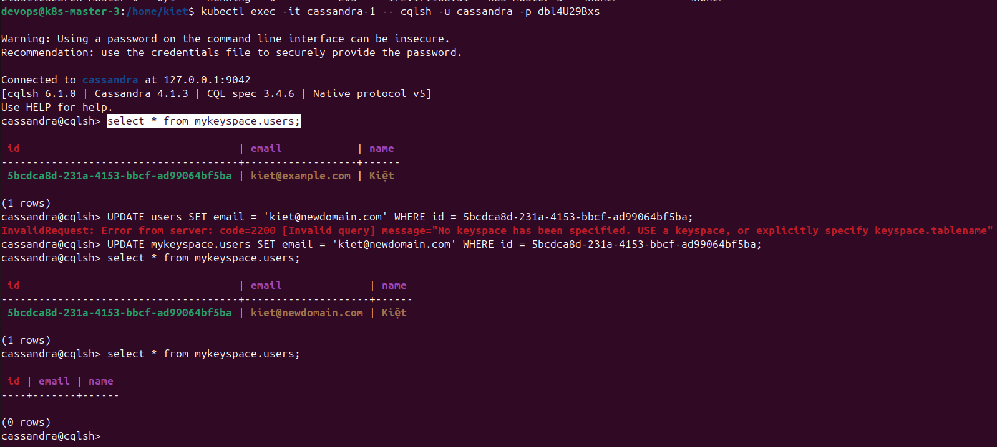

* check pods and all-namespaces:

kubectl get pods -o wide

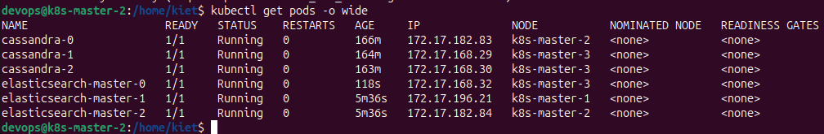

kubectl get pods -o wide --all-namespaces

